EPUT Public Sector Equality Duty Report
April 2022 – March 2023

CONTENTS

Section Page

Introduction 3

- The Equality Delivery System and our Equality Objectives 3

- The Workforce Race / Disability Equality Standards 4

- Gender Pay Gap Reporting 4

- Summary of Milestones for 2021 – 2022 4

- Reporting 5

- Local Demographics 5

- Staff In Post 8

- New Starters 14

- Promotions 18

- Leavers 22

- Recruitment 29

- Employee Relations 30

- Conclusion 34

INTRODUCTION

The Trust is legally required to monitor, analyse and publish equality, diversity and inclusion data as part of its commitment to the Public Sector Equality Duty (2018) by March on an annual basis. The information covers the protected characteristics within the Equality Act 2010 (Age, Disability, Gender Reassignment, Marriage and Civil Partnership, Pregnancy & Maternity, Race (Ethnicity), Religion & Belief, Sex and Sexual Orientation).

In summary, those subject to the general equality duty must, in the exercise of their functions, have due regard to the need to:

- Eliminate unlawful discrimination, harassment and victimisation and other conduct prohibited by the Act.
- Advance equality of opportunity between people who share a protected characteristic and those who do not.
- Foster good relations between people who share a protected characteristic and those who do not.

The Act explains that the second aim (advancing equality of opportunity) involves, in particular, having due regard to the need to:

- Remove or minimise disadvantages suffered by people due to their protected characteristics.
- Take steps to meet the needs of people with certain protected characteristics where these are different from the needs of other people.
- Encourage people with certain protected characteristics to participate in public life or in other activities where their participation is disproportionately low.

This report will illustrate EPUT’s commitment and development by complying with the duties of the Public Sector Equality Duty (PSED):

- Reporting of Gender Pay Gap within our organisation.
- Compliance with the General Equality Duty by breakdown of employee demographic
- By listing our aims and objectives to further achieve the aims of the PSED.

This report will present data (taken from 1st April 2021 – 31st March 2022) relating to: staff in post, starters, promotions, leavers, recruitment, employee relations and appraisals. This will include both contractual arrangements (permanent, fixed term and bank workers) and all pay bandings. Analysing the data allows us to establish progress and areas of concern, which can then be fed into directorate action plans as well as the EDI Framework, which is monitored by the Equality and Inclusion Sub-Committee and People Equality and Culture Committee (PECC).

Each year we are required to publish this information on our public website by 31st March.

- THE EQUALITY DELIVERY SYSTEM AND OUR EQUALITY OBJECTIVES

The Equality Delivery System (EDS) is a system that helps NHS organisations improve the services they provide for their local communities and provide better working environments, free of discrimination, for those who work in the NHS, while meeting the requirements of the Equality Act 2010.

In March 2023 two virtual equality and inclusion workshops were held, engaging our stakeholders (staff and patients) with examples of our achievements from 2022-23 and encouraging feedback to influence our goals and priorities for 2023-24.

As NHS England have developed a new format for the EDS and intend this to be completed collaboratively within ICS groups, this year has been seen as an implementation year. Due to our commitments with multiple ICS groups, we as an organisation are working to develop this structure for 2023-24, but this year have completed it independently and will be sharing this with our system partners. Our EDS (2022-23) action plan and grading report is published on the Trust website and will be available on the EDI Hub on the Trust intranet in March 2023.

The most recent version of this is available alongside other key Equality and Inclusion Documents (available at https://eput.nhs.uk/about-us/equality-and-diversity)

- THE WORKFORCE RACE EQUALITY STANDARD AND WORKFORCE DISABILITY EQUALITY STANDARD

Our work around Race Equality and Disability Equality is captured in two separate reports, which are produced annually each September and set out our performance across a range of metrics. The most recently published Workforce Race Equality Standard (WRES) and Workforce Disability Equality Standard
(WDES) reports are available here: https://eput.nhs.uk/about-us/equality-and-diversity/delivering-equality/

- GENDER PAY GAP REPORTING

The gender pay gap shows the difference in the average pay between all men and women in a workforce. If a workforce has a particularly high gender pay gap, this can indicate there may be a number of issues to deal with, and the individual calculations may help to identify what those issues are. It is important to stress that the Gender Pay Gap is different to Equal Pay.

Equal pay deals with the pay differences between men and women who carry out the same jobs, similar jobs or work of equal value. It is unlawful to pay people unequally because they are a man or a woman. We are committed to a diverse workforce and the fair treatment and reward of all staff irrespective of gender. Our latest Gender Pay Gap reports are available here: https://eput.nhs.uk/media/32ga4vxa/eput-gender-pay-gap-report-mar-21.pdf

- SUMMARY OF MILESTONES FOR 2022 – 2023

Equality and inclusion remains a priority within the Trust and we are proud of the progress we have made towards our equality objectives in this period. Below are listed some of our main achievements in not only eliminating discrimination, but also promoting equality and inclusion in the workplace and ultimately into our services and patient care:

- Following WRES and WDES Data showing us that Bullying and Harassment needed to be addressed, we implemented the No Space for Abuse campaign in EPUT in conjunction with Essex Police and our Violence and Aggression Prevention and Reduction (VAPR) Team. This provides staff with both guidance on how to report racism or any form of discriminatory behaviour, as well as clear messaging that this is not accepted from people accessing our services.
- Continuation of our EPUT RISE programme, focusing on career development for black, asian and minority ethnicity (BME) staff across the Trust aimed at multiple bandings and skill levels. Participants are also taught mentoring skills as part of the programme to support less experienced members.
- Development of our Equality and Inclusion Strategy (2022-25), and approval at Board Level for implementation into the Trust.
- Executive Director Sponsors to join Staff Equality Networks, providing support to Network Chairs and acting as champion for the Network.
- Inclusive Career Development Workshop developed and presented in collaboration with Herts and West Essex ICS.
- Development and training of ER and Recruitment leads via the implementation of a De-Bias toolkit developed in collaboration with Mid and South Essex ICS, based on NHS England’s “No Tick Boxes” Guidance.
- Anti-Bullying Event held as part of EDI Week (November 10th 2022) held in collaboration with Mid and South Essex ICS.

- REPORTING

This report covers 1 April 2021 – 31 March 2022 (hereafter referred to as the reporting period).

The workforce data that is contained within this report has been obtained from various sources e.g. Electronic Staff Record (ESR), OLM Learning and records, and the NHS Jobs system. The staff profile is a snapshot from 31 March 2022.

The data includes all pay bands and staff groups including Agenda for Change (AfC) bands 1-9, Director and Senior Manager pay scales, Trust pay scales and Medical Staff pay scales. We also include bank staff. There is a small minority of staff who do not fit into these pay bands and are referred to in the category of “other”.

- LOCAL DEMOGRAPHICS

The benchmarking information in this report is taken from the National Census Information for 2021.

The overall analysis demonstrates that the Trust’s demographic profile when compared with the community profile shows us that in general, our workforce is representative of the community it serves. Where there are variations these are highlighted. This will be compared to the Census data 2021 in future reporting when it is made available.

The below data form part of the first set census of the population for England and wales. The population on
Essex on Census day 2021 was 1,503,300, not including Southend or Thurrock.

- The most populous districts in the county are Colchester, Basildon, and Chelmsford
- The least populous are Maldon, Brentwood, and Rochford
- The population of Essex has seen an increase of 109,713 over the last 10 years (since Census 2011) – an average annual growth rate of 0.76%
- Over the last 10 years, the population of Essex has grown at a faster rate than England (0.64% growth per year). Essex’s growth rate is similar to London (0.74% growth per year), though this may be in part due to the impact of the pandemic on where people were living on Census Day
- Every district & unitary within Greater Essex has seen their population increase since the 2011 Census. The areas with the highest average annual growth rate are Uttlesford, Harlow, and Thurrock. The areas with the lowest average annual growth rates are Castle Point, Rochford, and Southend
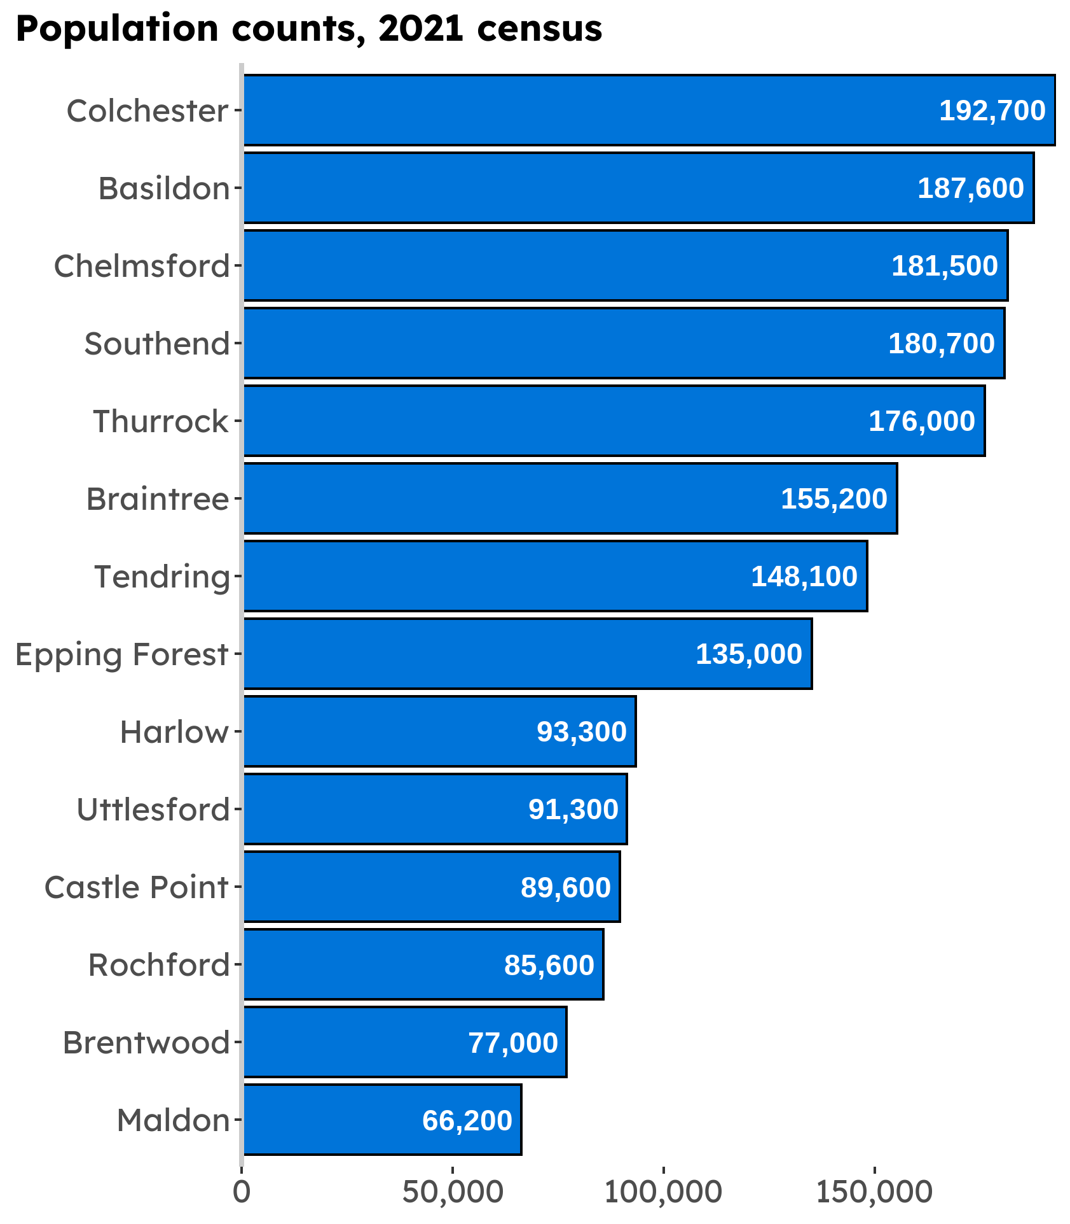
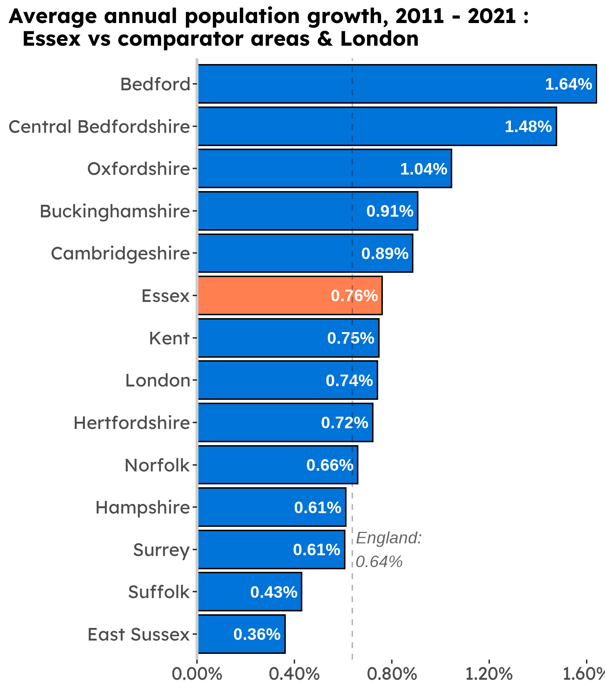

6.1 Ethnic Minority Groups
Collecting data on ethnicity groups is complex because of the subjective, multifaceted and changing nature of ethnicity identification. We as an organisation use Office of National Statistics (ONS) categories and membership is something that is self-defined and subjectively meaningful to the person concerned. This data is collected in line with EPUT’s Equality Monitoring Policy and Procedure (CP27 / CPG27).
The terminology used to describe ethnicity groups has changed markedly over time, and however defined or measured, tends to evolve in the context of social and political attitudes or developments. Ethnic groups are also very diverse, encompassing common ancestry and elements of culture, identity, religion, language and physical appearance. The table below shows the ethnicity breakdown of the population we serve (as taken from the 2021 (census).
Essex - All ethnicity categories | Population
White British | 1,264,877
White Irish | 11,165
White Gypsy or Irish Traveller | 2,161
White other | 35,653
Mixed/Multiple ethnic group: White and Black Caribbean | 6,936
Mixed/Multiple ethnic group: White and Black African | 2,801
Mixed/Multiple ethnic group: White and Asian | 6,173
Mixed/Multiple ethnic group: Other mixed | 4,975
Mixed/Multiple ethnic group: total | 20,885
Asian/Asian British: Indian | 12,456
Asian/Asian British: Pakistani | 3,462
Asian/Asian British: Bangladeshi | 2,747
Asian/Asian British: Chinese | 6,361
Asian/Asian British: Asian | 9,834
Asian/Asian British total | 34,860
Black/African/Caribbean/Black British: African | 12,143
Black/African/Caribbean/Black British: Caribbean | 4,556
Black/African/Caribbean/Black British: Other Black | 2,010
Black/Black British (Total) | 18,709
Other ethnic group: Arab | 2,042
Other ethnic group: Any other ethnic group | 3,235
Other Ethnic Groups (Total) | 5,277
BME | 79,731
BME % | 5.72%

6.2 Other Demographics

Key findings for other demographic groups are compared against data provided from the last 2021 Census: National Demographic profile summarised in the table below:

2021 Census | National 2021 Results
Age | - Highest proportion of Age is 50 – 64
Ethnicity | - Asian, Asian British or Asian Welsh: 3.7%  - Black, Black British, Black Welsh, Caribbean or African: 2.5%  - Mixed or Multiple ethnic groups: 2.4%  - White: 90.4%  - Other ethnic group:1.0%
Disability | - Disabled under the Equality Act: Day-to-day activities limited a lot: 6.8%  - Disabled under the Equality Act: Day-to-day activities limited a little: 9.9%  - Not disabled under the Equality Act: Has long term physical or mental health condition but day-to-day activities are not limited: 7.1%  - Not disabled under the Equality Act: No long term physical or mental health conditions: 76.2%
Gender or Sex | - 51.3% Female  - 48.7% Male
Gender Reassignment | - Gender identity the same as sex registered at birth: 94.6%  - Gender identity different from sex registered at birth but no specific identity given: 0.1%  - Trans woman: 0.1%  - Trans man: 0.1%  - Non-binary: 0.0%  - All other gender identities: 0.0%  - Not answered: 5.0%
Marriage & Civil Partnership | - Never married and never registered a civil partnership: 33.9%  - Married or in a registered civil partnership: 47.7%  - Married: 47.5%  - In a registered civil partnership: 0.2%  - Separated, but still legally married or still legally in a civil partnership: 2.1%  - Divorced or civil partnership dissolved: 9.6%  - Widowed or surviving civil partnership partner: 6.6%
Pregnancy & Maternity | - No pregnancy or maternity status was collected during this Census
Religion & Belief | - No religion: 42.1%  - Christian: 47.9%  - Buddhist: 0.4%  - Hindu: 1.0%  - Jewish: 0.5%  - Muslim: 1.6%  - Sikh: 0.2%  - Other religion: 0.5%  - Not answered: 5.7%
Sexual Orientation | - Straight or Heterosexual: 91.3%  - Gay or Lesbian: 1.1%  - Bisexual: 0.9%  - Pansexual: 0.2%  - Asexual and “Queer”: 0.0%  - All other sexual orientations: 0.0%  - Not answered: 6.5%

- STAFF IN POST

The total headcount for Essex Partnership University NHS Foundation Trust (the Trust) on 31 March 2022 was 8884. This figure includes all permanent, fixed term and bank workers plus leavers during this period. This figure includes all geographical areas of the Trust during this reporting period. Bank workers are included in this report as we consider them an integral part of our workforce.

7.1 Ethnicity Profile of Staff in Post

The following ethnicity codes will be used as part of the data below, codes D – S represent ethnic minority groups and the term “BME” will be used to refer to this group for reporting purposes. A further explanation of Ethnicity Origin Codes and why these are used is available as part of our Equality Monitoring Policy (CP27 – Appendix A)

Code | Ethnic Origin | Code | Ethnic Origin
A | White - British | K | Asian or Asian British - Bangladeshi
B | White - Irish | L | Asian or Asian British – Any other Asian background
C | White-Any other White background | M | Black or Black British – Caribbean
D | Mixed – White & Black Caribbean | N | Black or Black British – African
E | Mixed – White & Black African | P | Black or Black British – Any other Black background
F | Mixed – White & Asian | R | Chinese
G | Mixed – Any other mixed background | S | Any other ethnic group
H | Asian or Asian British-Indian | U | Unknown / Not Stated
J | Asian or Asian British - Pakistani | Z | Unknown / Not Stated

Code | A | B | C | D | E | F | G | H | J | K | L | M | N | P | R | S | U | Z | Total
Number of Staff | 5657 | 117 | 576 | 34 | 34 | 38 | 57 | 270 | 59 | 49 | 158 | 97 | 1153 | 186 | 20 | 122 | 109 | 148 | 8884
% | 64 | 1 | 6 | 0.4 | 0.4 | 0.4 | 1 | 3 | 1 | 0.6 | 2 | 1 | 13 | 2 | 0.2 | 1 | 1 | 2 | 100%

The table above shows the ethnicity percentage breakdown of our workforce. This shows that 26% of our workforce is from a BME background, which in comparison to our local population (5.72%, Census 2021) is positive). Percentages were rounded up with scores below 1% rounded to one decimal place to accurately reflect the overall percentage.
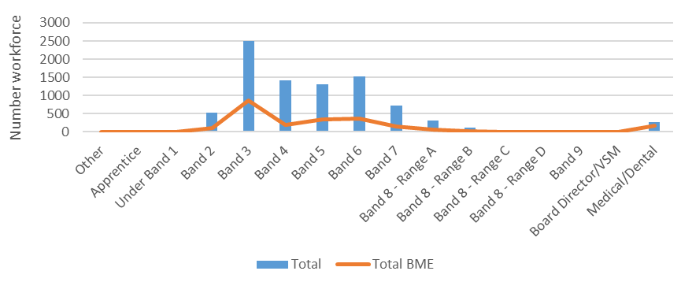
The Chart above breaks the workforce down further by ethnicity and band. The total percentage of staff from BME backgrounds overall was 26% which indicates a positive 1% increase from the 2022 report. The most highly populated banding for BME staff was Medical & Dental (63%), Apprentice level (50%) and Band 3 (34%). In comparison to 2021 data, we can see a shift from BME band 2 to BME Band 3; this suggests an increase in promotion from Band 2 to Band 3.

7.2 Disability of Staff in Post

AFC Banding
ESR Status | Other | Apprentice | Under Band 1 | Band 2 - 6 | Band 7 - 9 | Board Director / VSM |  | Medical/ Dental | Total Workforce | Total %
No | 11 | 15 | 11 | 5858 | 904 | 14 |  | 205 | 7018 | 79%
Not Declared | 5 | 0 | 3 | 733 | 223 | 0 |  | 37 | 1001 | 11%
Prefer Not To Answer | 0 | 0 | 0 | 13 | 1 | 0 |  | 0 | 14 | 0%
Unspecified | 1 | 0 | 0 | 384 | 69 | 0 |  | 13 | 467 | 5%
Yes | 1 | 1 | 3 | 313 | 59 | 2 |  | 5 | 384 | 4%
Total | 18 | 16 | 17 | 7301 | 1256 | 16 |  | 260 | 8884 | 100%
% of the band stating disability | 6% | 6% | 18% | 4% | 5% | 13% |  | 2% | 4%

The table above shows the disability breakdown of the Trusts workforce. 384 (4%) of staff identified as disabled during this reporting period, slightly higher than the previous year. This is lower than the 20% identified in the Census. We are aware that ESR data only accounts for staff in post who have chosen to declare a Disability. Work continues in the Trust to encourage our workforce update and feel confident in raising that they may have disabilities or long-term conditions, and to provide an environment where they feel supported in doing so and will receive appropriate reasonable adjustments.

We as a Trust are a Disability Confident Leader, and this supports us in our recruitment and support of those with disabilities and long-term conditions.

7.3 Gender Breakdown of Staff in Post
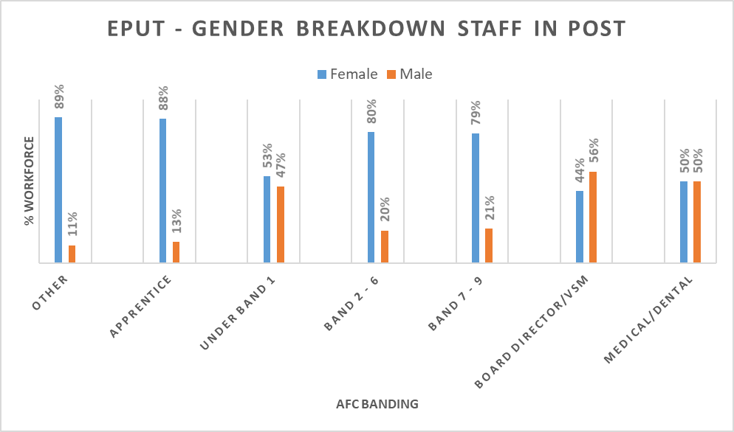
The chart above shows the gender breakdown of the Trust’s workforce. The Trust has a predominantly female workforce (6979); we can see a slight increase of our female workforce by 1% from the previous year’s report. During this period, 79% of our workforce were female and 21% were male. This is commensurate with the NHS as a whole, which is predominantly female, and higher than local demographics

It should be noted this report recognises the difference between anatomical sex and gender identity, and whilst there are a range of terms used to describe this spectrum, they are not currently options on ESR. Therefore, this reports staff responses only as recorded on ESR, and does not differentiate between transgender and cisgender staff members.

In comparison from the previous report, we saw see a change at senior management levels, During this period, 44% of EPUT’s senior management were female and 56% male. As opposed to the previous years report showing 63% senior management (Female) and 37% senior management (Male).

7.4 Religious Belief of Staff in Post

AFC Band | I do not wish to disclose  my religion/belief | Atheism | Christianity | Buddhism | Hinduism | Islam | Jainism | Judaism | Other | Sikhism | Un  specified | Total
Other | 3 | 6 | 7 | 0 | 0 | 0 | 0 | 0 | 1 | 0 | 1 | 18
Apprentice | 0 | 7 | 7 | 0 | 0 | 0 | 0 | 0 | 2 | 0 | 0 | 16
Under Band 1 | 3 | 8 | 2 | 0 | 0 | 1 | 0 | 0 | 3 | 0 | 0 | 17
Band 2 | 112 | 62 | 226 | 5 | 2 | 12 | 0 | 1 | 42 | 0 | 65 | 527
Band 3 | 453 | 320 | 1299 | 10 | 40 | 76 | 0 | 5 | 199 | 1 | 100 | 2503
Band 4 | 249 | 291 | 651 | 4 | 19 | 22 | 0 | 4 | 110 | 1 | 72 | 1423
Band 5 | 259 | 180 | 671 | 2 | 21 | 24 | 0 | 5 | 104 | 3 | 47 | 1316
Band 6 | 314 | 258 | 685 | 9 | 26 | 32 | 0 | 0 | 131 | 4 | 73 | 1532
Band 7 | 200 | 98 | 287 | 6 | 18 | 13 | 0 | 3 | 62 | 1 | 30 | 718
Band 8a | 68 | 70 | 134 | 2 | 5 | 4 | 0 | 1 | 15 | 2 | 16 | 317
Band 8b | 29 | 20 | 45 | 1 | 5 | 5 | 1 | 0 | 9 | 1 | 9 | 125
Band 8c | 13 | 4 | 20 | 0 | 2 | 1 | 0 | 1 | 4 | 1 | 4 | 50
Band 8d | 15 | 0 | 17 | 0 | 2 | 0 | 0 | 0 | 2 | 0 | 1 | 37
Band 9 | 1 | 2 | 5 | 0 | 0 | 0 | 0 | 1 | 0 | 0 | 0 | 9
Board Director/VSM | 3 | 2 | 7 | 0 | 1 | 1 | 0 | 0 | 2 | 0 | 0 | 16
Medical/Dental | 106 | 15 | 49 | 5 | 27 | 41 | 1 | 2 | 8 | 1 | 5 | 260
Total | 1828 | 1343 | 4112 | 44 | 168 | 232 | 2 | 23 | 694 | 15 | 423 | 8884
% | 21% | 15% | 46% | 0.5% | 2% | 3% | 0.02% | 0.3% | 8% | 0.2% | 5% | 100%

The table above shows the religious belief breakdown of the Trust’s workforce for all pay bands. It shows that the most highly represented religious belief within the workforce was Christianity at 46%. There was a high proportion of staff choosing not to disclose their religious belief (21%), whilst representation from other faith groups appears low. This may reflect the current Census with the rise in “No Religion” as a category across the UK.
7.5 Sexual Orientation of Staff in Post

AFC Band | Bisexual | Gay or Lesbian | Heterosexual | Not stated (person asked but declined to provide a response) | Other sexual orientation not listed | Undecided | Unspecified | Total
Other | 1 | 0 | 14 | 2 | 0 | 0 | 1 | 18
Apprentice | 1 | 0 | 14 | 1 | 0 | 0 | 0 | 16
Under Band 1 | 3 | 0 | 10 | 3 | 1 | 0 | 0 | 17
Band 2 | 5 | 2 | 366 | 88 | 1 | 0 | 65 | 527
Band 3 | 24 | 35 | 2016 | 326 | 3 | 2 | 97 | 2503
Band 4 | 18 | 33 | 1129 | 173 | 2 | 0 | 68 | 1423
Band 5 | 11 | 17 | 1019 | 222 | 2 | 0 | 45 | 1316
Band 6 | 12 | 20 | 1218 | 208 | 1 | 0 | 73 | 1532
Band 7 | 7 | 12 | 527 | 142 | 0 | 0 | 30 | 718
Band 8a | 1 | 9 | 247 | 44 | 0 | 0 | 16 | 317
Band 8b | 1 | 1 | 92 | 21 | 0 | 0 | 10 | 125
Band 8c | 1 | 2 | 36 | 8 | 0 | 0 | 3 | 50
Band 8d | 0 | 1 | 20 | 15 | 0 | 0 | 1 | 37
Band 9 | 0 | 0 | 9 | 0 | 0 | 0 | 0 | 9
Board Director/VSM | 0 | 1 | 13 | 2 | 0 | 0 | 0 | 16
Medical/Dental | 3 | 4 | 172 | 76 | 0 | 0 | 5 | 260
Total | 88 | 137 | 6902 | 1331 | 10 | 2 | 414 | 8884
% | 1% | 2% | 78% | 15% | 0.1% | 0.02% | 5% | 100%

The table above shows the sexual orientation breakdown of the Trust’s workforce for all pay bands. The highest proportion of staff declaring their sexual orientation is Heterosexual (78%) which is a 2% increase from the previous year’s report.

3.1% of the workforce declared their sexual orientation as Lesbian, Gay, Bisexual or Other (LGB+) which has remained the same as the previous year’s report (2021). There was a reduction in the percentage of staff choosing to not declare their sexual orientation; this decreased to 15%.

We as a Trust recognise that the current ESR data collected on a national level falls short on the recording of gender identity for our Transgender and Non-Binary staff members, and will include this in future reports as this is currently being reviewed at a national level and will be added to these systems by NHS England.

7.6 Age Profile of Staff in Post

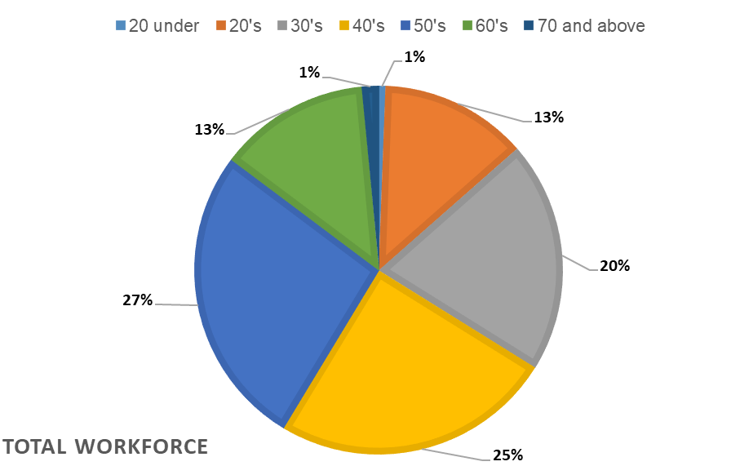

The above chart shows the percentage of workforce by age banding. The most highly populated age bands were made up of those aged in their 40’s and 50’s. This equates to 52% of our workforce. We as a Trust are continuing to develop our staff in younger age bands, as well as, retaining the key skills we already have in our workforce and encourage retired and return to enhance the experience and expertise within EPUT.

7.7 Marital Status of Staff in Post

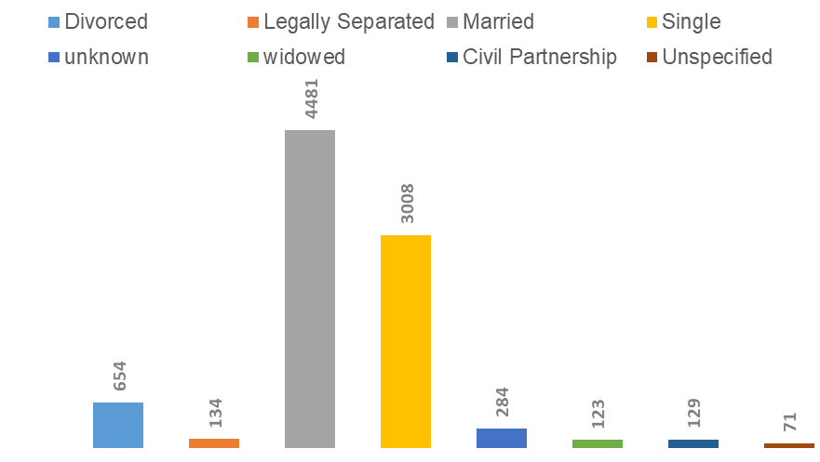
The chart above shows the marital status for all staff in post. The highest status was ‘Married’ with ‘Single’ after this. However since the previous report we have seen a slight decrease in the number of those listing themselves as divorced from 692 to 654, along with a decrease in the number reported being married from 4710 (2021) to 4481 (2022). We have also seen a decrease in those declaring Single status.

7.8 Maternity & Adoption Status of Staff in Post

FC Band | Acting Up | Active Assignment | Career Break | Internal Secondment | Maternity & Adoption | Out on External Secondment - Paid | Suspend No Pay | Suspend With Pay | Total
Total | 146 | 8466 | 8 | 122 | 127 | 10 | 1 | 4 | 8884
% | 2% | 95% | 0.1% | 1% | 1% | 0.1% | 0.01% | 0.05% | 100%
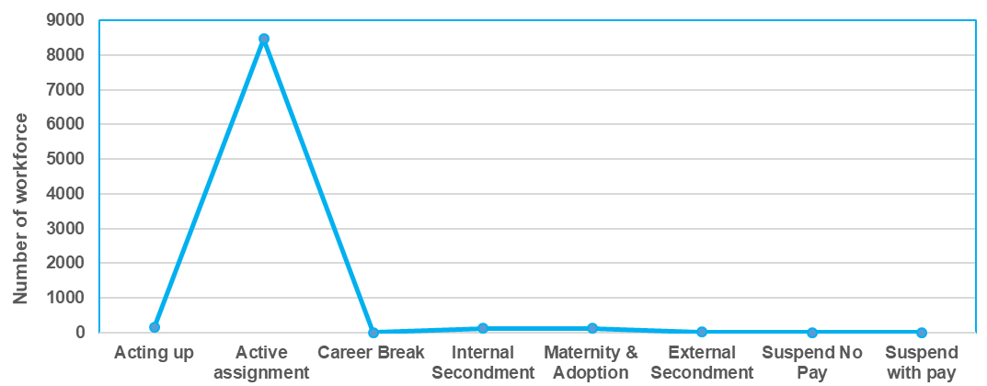

At the time of this report, the Trust had 127 employees on maternity or adoption leave, which equates to 1% of the workforce. During this period, there was also an increase in internal secondments across the Trust increasing from 94 (2021) to 122 (2022), along with an increase in staff “acting up” from 108 (2021) to 146 (2022) supporting further learning and development within the Trust.

- NEW STARTERS

There were 2250 new starters in EPUT during this reporting period, which was lower than the previous year (4027).

  - Ethnicity Breakdown of New Starters

 | Ethnicity Code – (D-S are codes for BME staff, listed in section 7.1)
AFC Band | A | B | C | D | E | F | G | H | J | K | L | M | N | P | R | S | U | Z | TOTAL | No. BME | % BME
Other | 6 | 0 | 0 | 0 | 0 | 0 | 0 | 0 | 0 | 0 | 0 | 1 | 2 | 0 | 0 | 0 | 0 | 0 | 9 | 3 | 33%
Apprentice | 6 | 1 | 1 | 0 | 0 | 0 | 0 | 0 | 0 | 0 | 0 | 3 | 3 | 0 | 0 | 0 | 0 | 0 | 14 | 6 | 43%
Under Band 1 | 62 | 0 | 12 | 2 | 1 | 3 | 0 | 0 | 1 | 0 | 2 | 1 | 4 | 0 | 0 | 1 | 0 | 1 | 90 | 15 | 17%
Band 2 | 108 | 3 | 11 | 4 | 2 | 1 | 1 | 5 | 0 | 1 | 2 | 3 | 54 | 8 | 0 | 1 | 6 | 4 | 214 | 82 | 38%
Band 3 | 314 | 4 | 24 | 2 | 2 | 3 | 3 | 5 | 5 | 9 | 8 | 5 | 58 | 15 | 0 | 3 | 3 | 4 | 467 | 118 | 25%
Band 4 | 261 | 9 | 33 | 2 | 3 | 1 | 4 | 27 | 6 | 4 | 9 | 7 | 30 | 9 | 3 | 5 | 13 | 6 | 432 | 110 | 25%
Band 5 | 252 | 6 | 28 | 0 | 2 | 2 | 3 | 10 | 1 | 3 | 6 | 6 | 53 | 8 | 2 | 4 | 10 | 9 | 405 | 100 | 25%
Band 6 | 207 | 10 | 17 | 2 | 0 | 3 | 5 | 14 | 4 | 3 | 7 | 5 | 37 | 8 | 2 | 4 | 12 | 7 | 347 | 94 | 27%
Band 7 | 70 | 3 | 13 | 0 | 0 | 0 | 2 | 5 | 2 | 1 | 2 | 0 | 12 | 2 | 0 | 2 | 1 | 2 | 117 | 28 | 24%
Band 8a | 31 | 2 | 8 | 0 | 0 | 0 | 1 | 0 | 0 | 1 | 3 | 1 | 2 | 0 | 0 | 0 | 0 | 0 | 49 | 8 | 16%
Band 8b | 15 | 1 | 2 | 0 | 0 | 0 | 0 | 0 | 1 | 1 | 1 | 0 | 1 | 0 | 0 | 0 | 0 | 0 | 22 | 4 | 18%
Band 8c | 3 | 1 | 0 | 0 | 0 | 0 | 0 | 2 | 0 | 0 | 0 | 0 | 0 | 0 | 0 | 0 | 0 | 0 | 6 | 2 | 33%
Band 8d | 6 | 0 | 0 | 0 | 0 | 0 | 0 | 1 | 0 | 0 | 0 | 0 | 1 | 0 | 0 | 0 | 1 | 0 | 9 | 2 | 22%
Band 9 | 1 | 0 | 0 | 0 | 0 | 0 | 0 | 0 | 0 | 0 | 0 | 0 | 1 | 0 | 0 | 0 | 0 | 0 | 2 | 1 | 50%
Board\ Director\ VSM | 1 | 0 | 0 | 0 | 0 | 0 | 0 | 0 | 0 | 0 | 0 | 0 | 0 | 0 | 0 | 0 | 0 | 0 | 1 | 0 | 0%
Medical\ Dental | 7 | 0 | 7 | 0 | 0 | 0 | 0 | 7 | 5 | 2 | 1 | 0 | 8 | 2 | 1 | 9 | 16 | 1 | 66 | 35 | 53%
TOTAL | 1,350 | 40 | 156 | 12 | 10 | 13 | 19 | 76 | 25 | 25 | 41 | 32 | 266 | 52 | 8 | 29 | 62 | 34 | 2,250 | 608 | 27%

The table above shows the ethnic breakdown of all new starters during this reporting period. The total percentage of all new starters from ethnic minority backgrounds during this reporting period was 27%, which is a slight increase from the previous year (20%). It is higher in comparison to our locality demographic (5.2%).

The Trust recognises there is more work and progression in appointing ethnic minority backgrounds; consult EPUT’s WRES (2022-23) report and action plan for the Trust’s actions to improve the experiences of BME staff groups within our workforce.

  - Disability Breakdown of new starters

 | AFC Banding
Disability declaration on ESR | Other | Apprentice | Under Band 1 | Band 2-6 | Band 7-9 | Board / Director / VSM | Medical / Dental | TOTAL | %
No | 7 | 13 | 67 | 1,698 | 182 | 1 | 52 | 2,020 | 90%
Not Declared | 1 | 0 | 7 | 49 | 3 | 0 | 0 | 60 | 3%
Preferred Not To Answer | 0 | 0 | 5 | 3 | 0 | 0 | 0 | 8 | 0.4%
Unspecified | 0 | 0 | 0 | 17 | 1 | 0 | 10 | 28 | 1.2%
Yes | 1 | 1 | 11 | 98 | 19 | 0 | 4 | 134 | 6%
Total Headcount of starters | 9 | 14 | 90 | 1,865 | 205 | 1 | 66 | 2,250 | 100%
% of new Starters who declared disability as “Yes” | 11% | 7% | 12% | 5% | 9% | 0% | 6% | 6%

The table below shows the disability breakdown of all new starters for this reporting period. It shows that overall 6% of new starters stated that they have a disability, which is an increase in comparison to the previous year (3%)

Consult EPUT’s WDES (2022 - 23) report and action plan for the Trust’s actions to improve the experiences of staff in our services with disabilities and long-term-conditions.

  - Gender Breakdown of New Starters

 |  | Gender
AFC Banding | Data | Female | Male | TOTAL
Other | Headcount | 7 | 2 | 9
Other | Percentage | 78% | 22% | 100%
Apprentice | Headcount | 13 | 1 | 14
Apprentice | Percentage | 93% | 7% | 100%
Under Band 1 |  | 53 | 37 | 90
Under Band 1 | Percentage | 59% | 41% | 100%
Band 2-6 | Headcount | 1526 | 339 | 1865
Band 2-6 | Percentage | 82% | 18% | 100%
Band 7-9 | Headcount | 158 | 47 | 205
Band 7-9 | Percentage | 77% | 23% | 100%
Board\Director\VSM | Headcount | 1 | 0 | 1
Board\Director\VSM | Percentage | 100% | 0% | 100%
Medical\Dental | Headcount | 40 | 26 | 66
Medical\Dental | Percentage | 61% | 39% | 100%
Total Headcount of starters |  | 1,798 | 452 | 2,250
Total % of starters |  | 80% | 20% | 100%
Staff in Post % |  | 79% | 21% | 100%

The table below shows the gender breakdown for all new starters. It shows that 80% new starters were female and 20% were male, this is reflective of the trusts overall workforce and significantly higher than our local population.

  - Religious Belief of New Starters

 | Religious Belief
AfC Band | I do not wish to disclose my religion / belief | Atheism | Christianity | Buddhism | Hinduism | Islam | Jainism | Judaism | Other | Sikhism | Unspec. | Total
Other | 0 | 0 | 0 | 0 | 0 | 0 | 0 | 0 | 0 | 0 | 0 | 0
TOTAL | 403 | 460 | 1,030 | 7 | 50 | 83 | 1 | 4 | 189 | 8 | 15 | 2,250
% | 18% | 20% | 46% | 0.3% | 2% | 4% | 0.04% | 0.2% | 8% | 0.4% | 1% | 100%
Staff in Post % | 21% | 15% | 46% | 0.5% | 2% | 3% | 0% | 0.3% | 8% | 0.2% | 5% | 100%

The table above shows the religious belief of all new starters. It can be seen that the highest representation of religious belief within new starters was Christianity. This is reflective of local demographics, however, the table also highlights that we have a high number of new starters who chose not to disclose this information (21%).

8.5 Sexual Orientation of New Starters

Sexual Orientation
AfC Band | Bisexual | Gay or Lesbian | Heterosexual | Not stated (person asked but declined to provide a response) | Other sexual orientation not listed | Undecided | Unspecified | TOTAL
TOTAL | 45 | 41 | 1,928 | 217 | 6 | 0 | 13 | 2,250
% | 2% | 2% | 86% | 10% | 0.3% | 0% | 1% | 100%
LGB Starters: 4%

The table above shows the sexual orientation of all new starters by band for this reporting period. The highest representation for sexual orientation in new starters was ‘Heterosexual’.

We as a Trust recognise that the current ESR data collected on a national level falls short on the recording of gender identity for our Transgender and Non-Binary staff members. We will include this in future reports when this is added to these systems, as this has been a concern raised with NHS England by our LGBTQ+ Staff Network.

Based on this data, 4% of our new starters were from an LGB background, the same as our results from the previous year.

  - Age Profile of New Starters

 | Age Band
Afc Band | 20 under | 20's | 30's | 40's | 50's | 60's | 70 and above | TOTAL
Other | 0 | 0 | 2 | 1 | 4 | 2 | 0 | 9
Apprentice | 1 | 4 | 6 | 3 | 0 | 0 | 0 | 14
Under Band 1 | 11 | 78 | 1 | 0 | 0 | 0 | 0 | 90
Band 2 | 8 | 53 | 36 | 54 | 42 | 19 | 2 | 214
Band 3 | 9 | 126 | 98 | 98 | 85 | 48 | 3 | 467
Band 4 | 1 | 143 | 118 | 67 | 70 | 29 | 4 | 432
Band 5 | 0 | 80 | 85 | 90 | 77 | 72 | 1 | 405
Band 6 | 0 | 40 | 110 | 83 | 69 | 42 | 3 | 347
Band 7 | 0 | 11 | 35 | 32 | 28 | 11 | 0 | 117
Band 8a | 0 | 4 | 17 | 12 | 11 | 5 | 0 | 49
Band 8b | 0 | 0 | 7 | 8 | 6 | 1 | 0 | 22
Band 8c | 0 | 0 | 1 | 1 | 2 | 2 | 0 | 6
Band 8d | 0 | 0 | 3 | 2 | 2 | 2 | 0 | 9
Band 9 | 0 | 0 | 1 | 0 | 1 | 0 | 0 | 2
Board Director/VSM | 0 | 0 | 0 | 0 | 1 | 0 | 0 | 1
Medical/Dental | 0 | 23 | 27 | 6 | 2 | 8 | 0 | 66
Total | 30 | 562 | 547 | 457 | 400 | 241 | 13 | 2250
% | 1% | 25% | 24% | 20% | 18% | 11% | 0.6% | 100%

The table below shows the age profile of all new starters. The data shows the highest percentage of new starters are those aged in their 20’s - 40’s.

8.6 Marital Status of New Starters

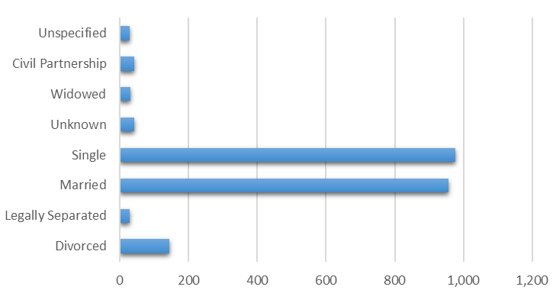

The graph above shows the marital status of new starters. The most highly declared category for marital status was ‘Single’. We can see a slight increase on ‘Single’ new starters as opposed to previous years the highest number being ‘Married’ this could be based on the Age profile of new starters within the Trust being hirer for the 20’ category.

- PROMOTIONS

There were 449 promotions during this reporting period (compared to 487 in 2019 - 20).

  - Ethnicity Breakdown of Promotions

(Ethnicity Code – D-S are codes for BME staff, listed in section 7.1)
AFC Band | A | B | C | D | E | F | G | H | J | K | L | M | N | P | R | S | U | Z | TOTAL | No. BME | BME % of Band
Apprentice | 1 | 0 | 0 | 0 | 0 | 0 | 0 | 0 | 0 | 0 | 0 | 2 | 1 | 0 | 0 | 0 | 0 | 0 | 4 | 3 | 75%
Under Band 1 | 6 | 0 | 2 | 0 | 0 | 0 | 0 | 0 | 0 | 0 | 0 | 0 | 0 | 0 | 0 | 0 | 0 | 0 | 8 | 0 | 0%
Band 2 | 212 | 5 | 38 | 1 | 8 | 2 | 4 | 14 | 3 | 6 | 16 | 9 | 323 | 63 | 1 | 11 | 10 | 6 | 732 | 461 | 63%
Band 3 | 112 | 3 | 6 | 1 | 2 | 1 | 0 | 1 | 0 | 0 | 1 | 1 | 5 | 0 | 0 | 0 | 1 | 2 | 136 | 12 | 9%
Band 4 | 41 | 0 | 2 | 0 | 0 | 1 | 0 | 1 | 0 | 0 | 2 | 0 | 3 | 0 | 0 | 0 | 0 | 0 | 50 | 7 | 14%
Band 5 | 115 | 1 | 8 | 1 | 1 | 1 | 1 | 1 | 1 | 0 | 4 | 1 | 29 | 4 | 0 | 4 | 0 | 3 | 175 | 48 | 27%
Band 6 | 95 | 2 | 9 | 1 | 1 | 0 | 0 | 2 | 0 | 1 | 1 | 2 | 23 | 2 | 1 | 3 | 0 | 2 | 145 | 37 | 26%
Band 7 | 33 | 1 | 4 | 1 | 0 | 0 | 4 | 1 | 0 | 0 | 0 | 1 | 8 | 1 | 0 | 0 | 0 | 0 | 54 | 16 | 30%
Band 8a | 14 | 0 | 2 | 0 | 0 | 0 | 0 | 1 | 0 | 0 | 0 | 0 | 0 | 0 | 0 | 0 | 0 | 1 | 18 | 1 | 6%
Band 8b | 3 | 1 | 1 | 0 | 0 | 0 | 0 | 0 | 0 | 0 | 0 | 0 | 2 | 0 | 0 | 0 | 0 | 0 | 7 | 2 | 29%
Band 8c | 0 | 0 | 0 | 0 | 0 | 0 | 0 | 0 | 0 | 0 | 0 | 0 | 0 | 0 | 0 | 0 | 0 | 0 | 0 | 0 | N/A
Band 8d | 3 | 0 | 2 | 0 | 0 | 0 | 0 | 0 | 0 | 0 | 0 | 0 | 0 | 0 | 0 | 0 | 0 | 0 | 5 | 0 | 0%
Band 9 | 0 | 0 | 0 | 0 | 0 | 0 | 0 | 0 | 0 | 0 | 0 | 0 | 1 | 0 | 0 | 0 | 0 | 0 | 1 | 1 | 100%
Board Director/VSM | 0 | 0 | 0 | 0 | 0 | 0 | 0 | 0 | 0 | 0 | 0 | 0 | 0 | 0 | 0 | 0 | 0 | 0 | 0 | 0 | N/A
Medical/Dental | 0 | 0 | 0 | 0 | 0 | 0 | 0 | 0 | 0 | 0 | 1 | 0 | 0 | 0 | 0 | 2 | 0 | 0 | 3 | 3 | 100%
TOTAL | 635 | 13 | 74 | 5 | 12 | 5 | 9 | 21 | 4 | 7 | 25 | 16 | 395 | 70 | 2 | 20 | 11 | 14 | 1338 | 591 | 44%

The table above shows the ethnicity breakdown of promotions for this reporting period. This shows that 44% of the staff promoted were from a BME background, a significant increase from the previous year (24%) and a strong indicator of positive development in our recruitment and shortlisting processes.

  - Disability Breakdown of Promotions

 | Disability status on ESR
AFC Band | No | Not Declared | Unspecified | Yes | TOTAL | Promotions % | Staff in Post %
Apprentice | 4 | 0 | 0 | 0 | 4 | 0% | 6%
Under Band 1 | 8 | 0 | 0 | 0 | 8 | 0% | 18%
Band 2 | 642 | 75 | 5 | 10 | 732 | 1% | 3%
Band 3 | 120 | 7 | 6 | 3 | 136 | 2% | 3%
Band 4 | 39 | 4 | 0 | 7 | 50 | 14% | 5%
Band 5 | 155 | 10 | 1 | 9 | 175 | 5% | 5%
Band 6 | 116 | 18 | 5 | 6 | 145 | 4% | 5%
Band 7 | 42 | 6 | 2 | 4 | 54 | 7% | 4%
Band 8a | 15 | 2 | 1 | 0 | 18 | 0% | 6%
Band 8b | 3 | 2 | 2 | 0 | 7 | 0% | 7%
Band 8c | 0 | 0 | 0 | 0 | 0 | N/A | 2%
Band 8d | 2 | 3 | 0 | 0 | 5 | 0% | 5%
Band 9 | 1 | 0 | 0 | 0 | 1 | 0% | 11%
Board Director/VSM | 0 | 0 | 0 | 0 | 0 | N/A | 13%
Medical/Dental | 2 | 1 | 0 | 0 | 3 | 0% | 2%
Total | 1149 | 128 | 22 | 39 | 1338 | 3% | 4%

The table above gives the disability breakdown for staff promoted during this reporting period. 3% of the staff that were promoted declared that they had a disability; this is 1% decrease in comparison to last year’s report.

  - Gender Breakdown of Promotions
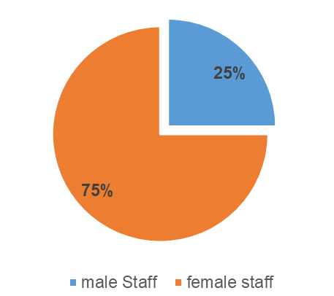

The pie chart above shows the percentage breakdown for male and female staff promotions during this reporting period. 75% of the promotions were female, 25% were male. This is in line with the demographics of the Trust and the NHS, but significantly higher than the local population.

  - Religious Belief of Promotions

AFC Band | I do not wish  to disclose my religion/belief | Atheism | Christianity | Buddhism | Hinduism | Islam | Jainism | Judaism | Other | Sikhism | Unspec.
Apprentice | 0 | 0 | 4 | 0 | 0 | 0 | 0 | 0 | 0 | 0 | 0
Under Band 1 | 0 | 5 | 1 | 0 | 0 | 0 | 0 | 0 | 2 | 0 | 0
Band 2 | 115 | 50 | 475 | 3 | 12 | 31 | 0 | 0 | 42 | 0 | 4
Band 3 | 22 | 34 | 59 | 0 | 0 | 1 | 0 | 0 | 14 | 0 | 6
Band 4 | 6 | 20 | 18 | 1 | 0 | 0 | 0 | 0 | 5 | 0 | 0
Band 5 | 20 | 38 | 86 | 1 | 3 | 5 | 0 | 1 | 18 | 1 | 2
Band 6 | 25 | 19 | 74 | 2 | 2 | 3 | 0 | 1 | 17 | 0 | 2
Band 7 | 9 | 15 | 23 | 1 | 1 | 0 | 0 | 0 | 3 | 0 | 2
Band 8a | 6 | 1 | 7 | 0 | 0 | 1 | 0 | 0 | 3 | 0 | 0
Band 8b | 1 | 0 | 4 | 0 | 0 | 0 | 0 | 0 | 0 | 0 | 2
Band 8c | 0 | 0 | 0 | 0 | 0 | 0 | 0 | 0 | 0 | 0 | 0
Band 8d | 2 | 1 | 1 | 0 | 0 | 0 | 0 | 1 | 0 | 0 | 0
Band 9 | 0 | 0 | 1 | 0 | 0 | 0 | 0 | 0 | 0 | 0 | 0
Board Director/VSM | 1 | 0 | 0 | 0 | 0 | 0 | 0 | 0 | 0 | 0 | 0
Medical/Dental | 2 | 0 | 0 | 0 | 0 | 1 | 0 | 0 | 0 | 0 | 0
TOTAL | 208 | 183 | 753 | 8 | 18 | 42 | 0 | 3 | 104 | 1 | 18
Promotions % | 16% | 14% | 56% | 1% | 1% | 3% | 0% | 0% | 8% | 0% | 1%
Staff in Post % | 21% | 15% | 46% | 0% | 2% | 3% | 0.02% | 0.3% | 8% | 0.2% | 5%

The table below gives the religious belief breakdown of promotions for this reporting period. The table shows that the highest number of promotions came from the faith category ‘Christianity’, which is representative of the underlying workforce. It is encouraging to see promotions in lower bands for all faith and spirituality groups, including lower populations in the organisation (Islam, Other, Hinduism.)

  - Sexual Orientation of Promotions
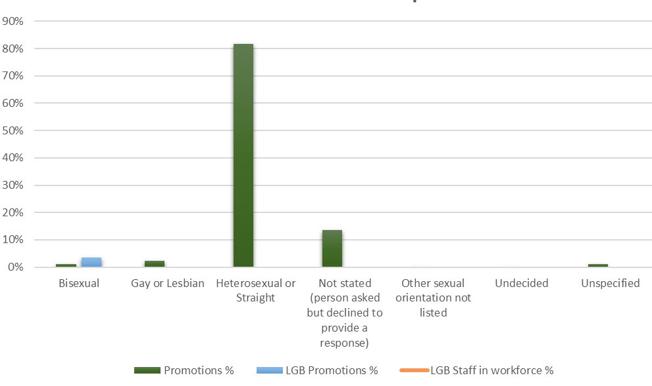
The graph above gives the sexual orientation for promotions during this reporting period. 3% (the same as the previous year’s report) of all promotions were undertaken by LGB staff, which is higher than the overall workforce figure.

  - Age Range Breakdown of Promotions

 | Age Band
AFC Band | 16-20 | 21-25 | 26-30 | 31-35 | 36-40 | 41-45 | 46-50 | 51-55 | 56-60 | 61-65 | 66-70 | 71 + | TOTAL
Apprentice | 1 | 0 | 1 | 0 | 2 | 0 | 0 | 0 | 0 | 0 | 0 | 0 | 4
Under Band 1 | 0 | 8 | 0 | 0 | 0 | 0 | 0 | 0 | 0 | 0 | 0 | 0 | 8
Band 2 | 14 | 71 | 58 | 74 | 81 | 111 | 105 | 99 | 70 | 34 | 13 | 2 | 732
Band 3 | 2 | 9 | 17 | 9 | 17 | 20 | 22 | 20 | 15 | 3 | 2 | 0 | 136
Band 4 | 1 | 13 | 10 | 7 | 3 | 4 | 5 | 5 | 2 | 0 | 0 | 0 | 50
Band 5 | 0 | 20 | 33 | 22 | 15 | 28 | 22 | 17 | 12 | 5 | 1 | 0 | 175
Band 6 | 0 | 4 | 24 | 19 | 21 | 27 | 21 | 16 | 7 | 4 | 1 | 1 | 145
Band 7 | 0 | 1 | 2 | 13 | 8 | 8 | 8 | 7 | 4 | 3 | 0 | 0 | 54
Band 8a | 0 | 0 | 1 | 4 | 2 | 3 | 1 | 4 | 2 | 1 | 0 | 0 | 18
Band 8b | 0 | 0 | 0 | 0 | 0 | 1 | 6 | 0 | 0 | 0 | 0 | 0 | 7
Band 8c | 0 | 0 | 0 | 0 | 0 | 0 | 0 | 0 | 0 | 0 | 0 | 0 | 0
Band 8d | 0 | 0 | 0 | 0 | 0 | 2 | 1 | 2 | 0 | 0 | 0 | 0 | 5
Band 9 | 0 | 0 | 0 | 1 | 0 | 0 | 0 | 0 | 0 | 0 | 0 | 0 | 1
Board Director/VSM | 0 | 0 | 0 | 0 | 0 | 0 | 0 | 0 | 0 | 0 | 0 | 0 | 0
Medical/Dental | 0 | 0 | 0 | 1 | 0 | 2 | 0 | 0 | 0 | 0 | 0 | 0 | 3
TOTAL | 18 | 126 | 146 | 150 | 149 | 206 | 191 | 170 | 112 | 50 | 17 | 3 | 1338

The table above gives the age range of promotions during this reporting period. Whilst there appear to be no trends, the data has lower numbers for younger and older adults in our workforce with promotions appearing to happen most frequently for our workforce between 26 – 60 years of age. Overall, there appear to have been more promotions than the last reported year.

- LEAVERS

Turnover is calculated by dividing the total number of leavers in a period by a combined figure of staff in post at the beginning and end of the period. Our overall turnover rate was 16%, an increase on previous years report (9%). At the time of reporting, there were 2208 leavers in the Trust for this reporting period. 43% of exits were planned and 57% were unplanned exits.

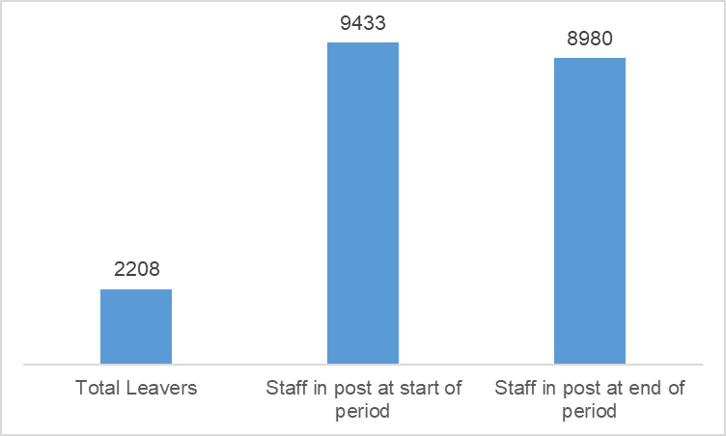

Planned / Unplanned Turnover | Reason for Leaving | TOTAL
Planned | Employee Transfer | 0
Planned | End of Fixed Term Contract | 26
Planned | End of Fixed Term Contract - Completion of Training Scheme | 20
Planned | End of Fixed Term Contract - End of Work Requirement | 7
Planned | End of Fixed Term Contract - Other | 14
Planned | Flexi Retirement | 0
Planned | Merged Organisation - Duplicate Record | 1
Planned | Mutually Agreed Resignation - Local Scheme with Repayment | 0
Planned | Redundancy - Compulsory | 4
Planned | Retirement - Ill Health | 7
Planned | Retirement Age | 162
Planned | Voluntary Early Retirement - no Actuarial Reduction | 6
Planned | Voluntary Early Retirement - with Actuarial Reduction | 7
Planned | Bank Staff not fulfilled minimum work requirement | 687
Planned | End of Fixed Term Contract - External Rotation | 2
Planned Total |  | 943
Unplanned | Death in Service | 9
Unplanned | Dismissal - Capability | 4
Unplanned | Dismissal - Conduct | 8
Unplanned | Dismissal - Some Other Substantial Reason | 17
Unplanned | Dismissal - Statutory Reason | 1
Unplanned | Voluntary Resignation - Adult Dependants | 5
Unplanned | Voluntary Resignation - Better Reward Package | 21
Unplanned | Voluntary Resignation - Child Dependants | 4
Unplanned | Voluntary Resignation - Health | 43
Unplanned | Voluntary Resignation - Incompatible Working Relationships | 14
Unplanned | Voluntary Resignation - Lack of Opportunities | 10
Unplanned | Voluntary Resignation - Other/Not Known | 916
Unplanned | Voluntary Resignation - Promotion | 61
Unplanned | Voluntary Resignation - Relocation | 51
Unplanned | Voluntary Resignation - To undertake further education or training | 27
Unplanned | Voluntary Resignation - Work Life Balance | 74
Unplanned Total |  | 1265
TOTAL |  | 2208

  - Ethnicity Breakdown of Leavers
 | Ethnicity Code – (D-S are codes for BME staff, listed in section 7.1) |  |  |  |  |  |  |  |  |  |  |  |  |  |  |  |  | Unknown / Not Declared |  |  | Totals and Percentages
AfC Band | A | B | C | D | E | F | G | H | J | K | L | M | N | P | R | S | U |  | Z | TOTAL |  | No. BME | BME % | BME % Overall Workforce
Other | 6 | 0 | 1 | 0 | 0 | 0 | 1 | 0 | 0 | 0 | 0 | 0 | 0 | 0 | 0 | 0 | 1 |  | 0 | 9 |  | 1 | 11% | 17%
Apprentice | 0 | 0 | 1 | 0 | 0 | 0 | 0 | 0 | 0 | 0 | 0 | 0 | 1 | 0 | 0 | 0 | 0 |  | 0 | 2 |  | 1 | 50% | 50%
Under Band 1 | 20 | 0 | 7 | 1 | 0 | 2 | 0 | 0 | 1 | 0 | 1 | 1 | 1 | 0 | 0 | 0 | 0 |  | 0 | 34 |  | 7 | 21% | 12%
Band 2 | 131 | 1 | 8 | 1 | 3 | 0 | 1 | 5 | 1 | 2 | 1 | 6 | 78 | 18 | 1 | 5 | 8 |  | 3 | 273 |  | 122 | 45% | 18%
Band 3 | 370 | 3 | 26 | 7 | 2 | 3 | 5 | 15 | 5 | 2 | 6 | 1 | 58 | 8 | 1 | 4 | 5 |  | 8 | 529 |  | 117 | 22% | 34%
Band 4 | 448 | 10 | 49 | 2 | 5 | 4 | 5 | 7 | 4 | 2 | 6 | 4 | 21 | 6 | 3 | 1 | 9 |  | 4 | 590 |  | 70 | 12% | 13%
Band 5 | 220 | 4 | 13 | 1 | 3 | 1 | 3 | 4 | 2 | 0 | 6 | 3 | 54 | 7 | 0 | 2 | 8 |  | 12 | 343 |  | 86 | 25% | 26%
Band 6 | 157 | 8 | 14 | 0 | 0 | 0 | 2 | 1 | 0 | 3 | 3 | 4 | 22 | 5 | 3 | 1 | 13 |  | 4 | 240 |  | 44 | 18% | 24%
Band 7 | 52 | 0 | 8 | 0 | 0 | 0 | 0 | 0 | 2 | 1 | 0 | 1 | 7 | 3 | 0 | 3 | 2 |  | 2 | 81 |  | 17 | 21% | 21%
Band 8 - Range A | 24 | 2 | 7 | 1 | 0 | 0 | 0 | 1 | 0 | 0 | 0 | 1 | 0 | 0 | 0 | 0 | 0 |  | 0 | 36 |  | 3 | 8% | 19%
Band 8 - Range B | 6 | 1 | 2 | 0 | 1 | 0 | 0 | 1 | 0 | 1 | 0 | 0 | 2 | 0 | 0 | 0 | 1 |  | 0 | 15 |  | 5 | 33% | 19%
Band 8 - Range C | 3 | 1 | 1 | 0 | 0 | 0 | 0 | 1 | 0 | 0 | 0 | 0 | 0 | 0 | 0 | 0 | 0 |  | 0 | 6 |  | 1 | 17% | 16%
Band 8 - Range D | 5 | 0 | 2 | 0 | 0 | 0 | 0 | 0 | 0 | 0 | 0 | 0 | 0 | 0 | 0 | 0 | 0 |  | 0 | 7 |  | 0 | 0% | 14%
Band 9 | 3 | 1 | 0 | 0 | 0 | 0 | 0 | 0 | 0 | 0 | 0 | 0 | 1 | 0 | 0 | 0 | 0 |  | 0 | 5 |  | 1 | 20% | 0%
Board Director/VSM | 1 | 0 | 0 | 0 | 0 | 0 | 0 | 0 | 0 | 0 | 0 | 0 | 0 | 0 | 0 | 0 | 0 |  | 0 | 1 |  | 0 | 0% | 25%
Medical/Dental | 10 | 0 | 4 | 0 | 1 | 1 | 0 | 3 | 4 | 1 | 2 | 0 | 6 | 0 | 0 | 3 | 1 |  | 1 | 37 |  | 21 | 57% | 63%
Total | 1456 | 31 | 143 | 13 | 15 | 11 | 17 | 38 | 19 | 12 | 25 | 21 | 251 | 47 | 8 | 19 | 48 |  | 34 | 2208 |  | 496 | 22% | 26%

The table above shows the ethnic breakdown of leavers for this reporting period. 22% of leavers were from ethnic minority groups, which is slightly lower than the workforce BME population of 26%.

  - Disability Breakdown of Leavers

 | Afc Banding
Disabled | Other | Apprentice | Under Band 1 | Band 2 - 6 | Band 7 - 9 | Board Director / VSM | Medical/Dental | TOTAL
No | 3 | 2 | 23 | 1706 | 106 | 0 | 33 | 1873
Not Declared | 4 | 0 | 3 | 117 | 26 | 1 | 2 | 153
Prefer Not To Answer | 0 | 0 | 4 | 5 | 0 | 0 | 0 | 9
Unspecified | 1 | 0 | 0 | 65 | 14 | 0 | 1 | 81
Yes | 1 | 0 | 4 | 82 | 4 | 0 | 1 | 92
TOTAL | 9 | 2 | 34 | 1975 | 150 | 1 | 37 | 2208
Leavers % of staff stating that they have a Disability | 11% | 0% | 12% | 4% | 3% | 0% | 3% | 4%
Staff in post % stating they have a disability | 6% | 6% | 18% | 4% | 5% | 13% | 2% | 4%

Based on the data above, 4% of all leavers during this period identified themselves as having a disability on ESR; this is lower than in comparison to 5% in the previous year.

10.3 Gender Breakdown of Leavers

 | Gender
AFC Banding | Data | Female | Male | TOTAL
Other | Headcount | 5 | 4 | 9
Other | Percentage | 56% | 44% | 100%
Apprentice | Headcount | 2 | 0 | 2
Apprentice | Percentage | 100% | 0% | 100%
Under Band 1 | Headcount | 22 | 12 | 34
Under Band 1 | Percentage | 65% | 35% | 100%
Band 2-6 | Headcount | 1548 | 427 | 1975
Band 2-6 | Percentage | 78% | 22% | 100%
Band 7-9 | Headcount | 119 | 31 | 150
Band 7-9 | Percentage | 79% | 21% | 100%
Board\Director\VSM | Headcount | 1 | 0 | 1
Board\Director\VSM | Percentage | 100% | 0% | 100%
Medical\Dental | Headcount | 20 | 17 | 37
Medical\Dental | Percentage | 54% | 46% | 100%
Total Headcount |  | 1,717 | 491 | 2,208
Total % |  | 78% | 22% | 100%
Staff in Post % |  | 79% | 21% | 100%
Of all leavers during this period – 78% were female and 22% were male, which is proportionate to the overall workforce.

10.4 Religious Belief of Leavers

AfC Band | I do not wish to disclose my religion / belief | Atheism | Christianity | Buddhism | Hinduism | Islam | Jainism | Judaism | Other | Sikhism | Unspecified | TOTAL
Other | 3 | 1 | 4 | 0 | 0 | 0 | 0 | 0 | 0 | 0 | 1 | 9
Apprent. | 0 | 0 | 1 | 0 | 0 | 1 | 0 | 0 | 0 | 0 | 0 | 2
Under Band 1 | 6 | 14 | 9 | 0 | 0 | 1 | 0 | 0 | 4 | 0 | 0 | 34
Band 2 | 38 | 45 | 152 | 0 | 3 | 7 | 0 | 0 | 18 | 0 | 10 | 273
Band 3 | 106 | 111 | 239 | 0 | 6 | 8 | 1 | 1 | 42 | 0 | 15 | 529
Band 4 | 82 | 168 | 258 | 0 | 6 | 13 | 0 | 1 | 52 | 2 | 8 | 590
Band 5 | 72 | 49 | 176 | 1 | 5 | 7 | 0 | 1 | 21 | 2 | 9 | 343
Band 6 | 53 | 47 | 106 | 2 | 2 | 6 | 0 | 1 | 14 | 0 | 9 | 240
Band 7 | 24 | 9 | 37 | 1 | 1 | 1 | 0 | 0 | 2 | 0 | 6 | 81
Band 8a | 12 | 5 | 10 | 0 | 0 | 0 | 0 | 1 | 6 | 1 | 1 | 36
Band 8b | 2 | 2 | 5 | 1 | 0 | 1 | 0 | 0 | 1 | 0 | 3 | 15
Band 8c | 3 | 2 | 0 | 0 | 0 | 0 | 0 | 0 | 0 | 0 | 1 | 6
Band 8d | 2 | 0 | 4 | 0 | 0 | 0 | 0 | 0 | 1 | 0 | 0 | 7
Band 9 | 1 | 1 | 3 | 0 | 0 | 0 | 0 | 0 | 0 | 0 | 0 | 5
Board Director / VSM | 1 | 0 | 0 | 0 | 0 | 0 | 0 | 0 | 0 | 0 | 0 | 1
Medical / Dental | 14 | 4 | 10 | 0 | 0 | 8 | 0 | 0 | 0 | 0 | 1 | 37
Total | 419 | 458 | 1014 | 5 | 23 | 53 | 1 | 5 | 161 | 5 | 64 | 2208
Leavers % | 19% | 21% | 46% | 0.2% | 1% | 2% | 0.05% | 0.2% | 7% | 0.2% | 3% | 100%

The highest percentage of leavers is from the Christianity category. Which is proportionate to the overall workforce.

10.5 Sexual Orientation of Leavers

 | Sexual Orientation
AFC Band | Bisexual | Gay or Lesbian | Heterosexual or “Straight” | Not stated (person asked but declined to provide a response) | Other sexual orientation not listed | Undecided | Unspecified | TOTAL
Other | 0 | 0 | 5 | 3 | 0 | 0 | 1 | 9
Apprentice | 0 | 0 | 1 | 1 | 0 | 0 | 0 | 2
Under Band 1 | 2 | 4 | 24 | 4 | 0 | 0 | 0 | 34
Band 2 | 3 | 3 | 223 | 34 | 1 | 0 | 9 | 273
Band 3 | 7 | 16 | 415 | 77 | 0 | 0 | 14 | 529
Band 4 | 8 | 14 | 482 | 79 | 0 | 0 | 7 | 590
Band 5 | 5 | 5 | 270 | 54 | 0 | 1 | 8 | 343
Band 6 | 2 | 3 | 193 | 34 | 0 | 0 | 8 | 240
Band 7 | 3 | 2 | 52 | 19 | 0 | 0 | 5 | 81
Band 8a up to Board / Director / VSM | 1 | 2 | 49 | 14 | 0 | 0 | 4 | 70
Medical/Dental | 0 | 0 | 29 | 7 | 0 | 0 | 1 | 37
TOTAL | 31 | 49 | 1743 | 326 | 1 | 1 | 57 | 2208
% of Total Leavers | 1% | 2% | 79% | 15% | 0.05% | 0.05% | 3% | 100%
Leavers LGB % | 4%
Staff in post LGB % | 3%

The table above shows that 4% of leavers were LGB compared to 2% of LGB leavers last year. This could be in part due to increased declarations from staff due to our work in the Trust. Whilst this is proportionate to the overall Trust, it may indicate that we are not meeting the needs of this community.

We as a Trust recognise that the current ESR data collected on a national level falls short on the recording of gender identity for our Transgender and Non-Binary staff members, and will include this in future reports as this is due to be added to these systems by NHS England. This has been a concern raised with NHS England by our LGBTQ+ Staff Network.

10.6 Age Range Breakdown of Leavers

 | Age Band
Afc Band | 20 under | 20's | 30's | 40's | 50's | 60's | 70 and above | TOTAL
Other | 0 | 0 | 0 | 1 | 3 | 1 | 4 | 9
Apprentice | 0 | 1 | 1 | 0 | 0 | 0 | 0 | 2
Under Band 1 | 3 | 30 | 1 | 0 | 0 | 0 | 0 | 34
Band 2 | 6 | 69 | 45 | 71 | 46 | 31 | 5 | 273
Band 3 | 9 | 107 | 88 | 96 | 132 | 89 | 8 | 529
Band 4 | 1 | 150 | 107 | 88 | 121 | 113 | 10 | 590
Band 5 | 0 | 46 | 66 | 76 | 74 | 78 | 3 | 343
Band 6 | 0 | 30 | 49 | 62 | 60 | 39 | 0 | 240
Band 7 | 0 | 3 | 21 | 11 | 27 | 18 | 1 | 81
Band 8a | 0 | 1 | 11 | 6 | 12 | 5 | 1 | 36
Band 8b | 0 | 0 | 3 | 5 | 6 | 1 | 0 | 15
Band 8c | 0 | 0 | 1 | 1 | 2 | 2 | 0 | 6
Band 8d | 0 | 0 | 1 | 0 | 4 | 2 | 0 | 7
Band 9 | 0 | 0 | 1 | 0 | 3 | 1 | 0 | 5
Board Director/VSM | 0 | 0 | 0 | 0 | 0 | 1 | 0 | 1
Medical/Dental | 0 | 9 | 14 | 4 | 4 | 5 | 1 | 37
TOTAL | 19 | 446 | 409 | 421 | 494 | 386 | 33 | 2208
% | 1% | 20% | 19% | 19% | 22% | 18% | 1% | 100%

The table below shows the age range breakdown for all leavers. There appears to be an equal rate of leavers across these age bands, with staff groups aged between 20 – 60 all having similar rates of leaving. The leaver’s age has increase to 60 as opposed to the previous year where we saw the age gap was set at 50.

- RECRUITMENT

The Trust uses Trac / NHS Jobs for all its recruitment activity. Recruiting managers do not have access to view the applicant’s personal details or monitoring information on their completed applications, including the equality streams.

It should also be noted that new additions to TRAC as part of General Data Protection Regulations (GDPR) have limited the data available for this period. Whilst 2022-23 presented pressures that prevented the EDI team from accessing this data, as this was requested outside of the one-year window. The creation of the PSED for 2023-24 will begin in Q2 mitigate this and provide greater context for the reporting that follows. Using WRES / WDES Data, the following updates are available:

- During this period, 8878 members of staff (including Bank Staff) were listed as employed by the Trust.
- During this period, 9693 potential candidates were shortlisted, 1148 were appointed from shortlisting.

WRES 2022-23 | Results
White Staff shortlisted | 2396
Staff from BME ethnicity groups shortlisted | 1446
White Staff appointed | 780
Staff from BME ethnicity groups appointed | 327
Likelihood of appointment from shortlisting based on data (White) | 33.55%
Likelihood of appointment from shortlisting based on data (BME) | 22.61%
WDES 2022-23
Non-disabled staff shortlisted | 8781
Staff with a disability or long-term condition shortlisted | 576
Non-disabled staff during this period appointed | 1002
Staff with a disability or long term condition appointed | 81
Likelihood of appointment from shortlisting based on data (non-disabled) | 11.41%
Likelihood of appointment from shortlisting based on data (disability or LTC) | 14.06%

This data suggests disparities in the likelihood of being appointed from shortlisting based on ethnicity during this period. The EDI Team has already been working closely with the Recruitment Team and our System partners to ensure our recruitment process is free from bias.

12.0 EMPLOYEE RELATIONS (ER)

Data in this category includes the number of staff subjected to a disciplinary hearing, the number of staff submitting formal grievances and the number of staff who have been the subject of investigation and capability procedures. The data also covers allegations made of bullying and harassment (Dignity at Work).

For this report, the data includes live cases at the time of the reporting period. The data includes all staff (permanent and bank workers) across all pay bands.

Type / Category (reporting only) | 2020 / 2021 | 2021 / 2022
Capability | 12 | 26
Dignity at Work | 27 | 38
Conduct | 54 | 44
Temporary Worker Conduct | 28 | 52
Flexible Working | 42 | 160
Grievance | 13 | 20
Temporary Worker Complaint | 13 | 8
TOTAL | 189 | 348

The table above reports a significant increase in 2021 / 2022 across many of these categories, it should be noted that during this reporting period, the Employee Relations Team has undertaken extensive work to address this process, with a goal to reduce the number of staff entering formal processes.

  - Ethnic breakdown of staff using or subjected to these procedures

Ethnicity | Capability | Dignity at Work | Conduct | Temporary Worker Conduct | Flexible Working | Grievance | Temporary Worker Complaints | TOTAL | % of all cases
A | 17 | 20 | 20 | 4 | 108 | 8 | 3 | 180 | 52%
B | 1 | 2 | 0 | 0 | 0 | 2 | 1 | 6 | 2%
C | 1 | 2 | 3 | 2 | 13 | 0 | 0 | 21 | 6%
D | 0 | 0 | 0 | 0 | 3 | 0 | 0 | 3 | 1%
E | 1 | 4 | 0 | 2 | 0 | 1 | 0 | 8 | 2%
F | 0 | 0 | 0 | 0 | 1 | 0 | 1 | 2 | 0.5%
G | 0 | 0 | 1 | 0 | 1 | 0 | 0 | 2 | 0.5%
H | 1 | 0 | 2 | 0 | 4 | 0 | 0 | 7 | 2%
J | 0 | 0 | 1 | 0 | 0 | 1 | 0 | 2 | 1%
K | 0 | 0 | 1 | 0 | 2 | 1 | 0 | 4 | 1%
L | 0 | 0 | 2 | 2 | 2 | 1 | 0 | 7 | 2%
M | 0 | 0 | 0 | 0 | 3 | 0 | 0 | 3 | 1%
N | 2 | 8 | 9 | 29 | 16 | 3 | 2 | 69 | 20%
P | 1 | 1 | 4 | 10 | 2 | 2 | 1 | 21 | 6%
R | 0 | 0 | 1 | 0 | 0 | 0 | 0 | 1 | 0%
S | 1 | 0 | 0 | 2 | 2 | 0 | 0 | 5 | 1%
U | 0 | 0 | 0 | 1 | 0 | 0 | 0 | 1 | 0%
Z | 1 | 1 | 0 | 0 | 3 | 1 | 0 | 6 | 2%
TOTAL | 26 | 38 | 44 | 52 | 160 | 20 | 8 | 348 | 100%
BME Total | 6 | 13 | 21 | 45 | 36 | 9 | 4 | 134 | 39%

The table on the previous page shows that, overall, most employee relations cases involve white British workers (52%), with (39%) being attributed to workers from an ethnic minority background.
During the period 2020 – 2021, 42 flexible working applications were received in comparison to 160 applications during 2021 – 2022.
During 2020-2021 there were just 54 substantive cases and 28 temporary worker conduct cases; during the period 2021-2022 there has been 348 reported cases under formal disciplinary with 134 being from BME staff. This has been an ongoing focus of both our WRES action planning, as well as encouraging further involvement of the Ethnic Minority and Race Equality Staff Network (EMREN).
12.2 Disability breakdown of staff using or subjected to these procedures

Declaration of Disability on ESR | Capability | Dignity at Work | Conduct | Temporary Worker Conduct | Flexible Working | Grievance | Temporary Worker Complaints | TOTAL | %
No | 11 | 23 | 33 | 42 | 121 | 15 | 4 | 249 | 71%
Not Declared | 11 | 13 | 8 | 10 | 30 | 4 | 3 | 79 | 23%
Yes | 4 | 2 | 3 | 0 | 9 | 1 | 1 | 20 | 6%
TOTAL | 26 | 38 | 44 | 52 | 160 | 20 | 8 | 348 | 100%

The table above includes staff from all bands including medical staff and those in both permanent and bank role. The Trust has seen a sufficient increase in majority of the categories in comparison to 2020/2021. The sufficient increase has been within Flexible working, in 2020/2021 reported to have 42 flexible working cases however, this has tripled in 2021/2022 to 160. These results could be the effect of recent changes to employment law for flexible working legislations and that many staff can work remotely in their roles.

  - Gender breakdown of staff using or subjected to these procedures

Type / Category (reporting only) | Female | Male
Capability | 16 | 10
Dignity at Work | 32 | 6
Conduct | 20 | 24
Temporary Worker Conduct | 30 | 22
Flexible Working | 125 | 35
Grievance | 13 | 7
Temporary Worker Complaints | 8 | 0
TOTAL | 244 | 104
% | 70% | 30%
Trust Staff in Post % | 79% | 21%

The table above shows the gender breakdown of staff using or subjected to these procedures during this reporting period. It should be noted that where the totals do not add up, it is because of an option where staff have chosen not to share their gender, but it is unknown if this is due to them having an alternative gender identity. It should be noted that there are very similar rates of “Conduct” procedures for both Male and Female staff despite the male group being nearly a quarter of the workforce.

12.4 Religious Belief breakdown of staff using or subjected to these procedures

AfC Band | I do not wish to disclose my religion / belief | Atheism | Christian | Hinduism | Islam | Judaism | Other | Sikhism | Unspe. | Total
Capability | 9 | 4 | 9 | 1 | 0 | 0 | 1 | 0 | 2 | 26
Dignity at Work | 15 | 2 | 18 | 0 | 0 | 0 | 1 | 0 | 2 | 38
Conduct | 6 | 10 | 15 | 5 | 1 | 0 | 6 | 0 | 1 | 44
Temporary Worker Conduct | 12 | 1 | 29 | 0 | 7 | 0 | 3 | 0 | 0 | 52
Flexible Working | 42 | 21 | 71 | 0 | 2 | 1 | 15 | 1 | 7 | 160
Grievance | 2 | 2 | 10 | 1 | 3 | 0 | 0 | 0 | 2 | 20
Temporary Worker Complaints | 3 | 0 | 4 | 0 | 1 | 0 | 0 | 0 | 0 | 8
TOTAL | 89 | 40 | 156 | 7 | 14 | 1 | 26 | 1 | 14 | 348
% | 26% | 11% | 45% | 2% | 4% | 0.5% | 7% | 0.5% | 4% | 100%

The table above shows the religion and faith breakdown of staff using or subjected to these procedures during this reporting period. It should be noted that Christianity is the highest declared religion on ESR, with “I do not wish to disclose my religion or belief” as the second highest category.

12.5 Sexual Orientation breakdown of staff using or subjected to these Procedures

Sexual Orientation | Capability | Dignity at Work | Conduct | Temporary Worker Conduct | Flexible Working | Grievance | Temporary Worker Complaints | TOTAL | %
Not stated (person asked but declined to provide a response) | 7 | 8 | 10 | 14 | 18 | 2 | 2 | 61 | 17%
Heterosexual or Straight | 17 | 27 | 33 | 36 | 130 | 15 | 6 | 264 | 76%
Bisexual | 0 | 0 | 0 | 1 | 2 | 0 | 0 | 3 | 1%
Gay or Lesbian | 0 | 1 | 0 | 1 | 4 | 1 | 0 | 7 | 2%
Unspecified | 2 | 2 | 1 | 0 | 6 | 2 | 0 | 13 | 4%
TOTAL | 26 | 38 | 44 | 52 | 160 | 20 | 8 | 348 | 100%

The table above shows the data for the Trust’s workforce and from all pay bands. The analysis shows that 17% (in comparison to 25% in the previous year) of those workers who have been subject of these ER procedures have chosen not to disclose their sexual orientation, a reduction from the previous year’s result and an indicator of improved declaration rates.

12.6 Age range of individuals using or subjected to these procedures

 | Capability | Dignity at Work | Conduct | Temporary Worker Conduct | Flexible Working | Grievance | Temporary Worker Complaint | Grand Total | %
16-20 | 0 | 0 | 1 | 0 | 3 | 0 | 1 | 5 | 1%
21-25 | 0 | 1 | 2 | 4 | 5 | 2 | 1 | 15 | 4%
26-30 | 1 | 2 | 5 | 1 | 21 | 2 | 0 | 32 | 9%
31-35 | 2 | 7 | 7 | 5 | 20 | 1 | 1 | 43 | 12%
36-40 | 3 | 4 | 2 | 5 | 29 | 2 | 0 | 45 | 13%
41-45 | 0 | 3 | 9 | 9 | 25 | 2 | 0 | 48 | 14%
46-50 | 2 | 5 | 5 | 7 | 17 | 3 | 1 | 40 | 11%
51-55 | 7 | 3 | 5 | 9 | 17 | 6 | 2 | 49 | 14%
56-60 | 8 | 8 | 4 | 5 | 15 | 1 | 0 | 41 | 12%
61-65 | 3 | 3 | 1 | 4 | 7 | 0 | 1 | 19 | 5%
66-70 | 0 | 2 | 3 | 3 | 1 | 0 | 0 | 9 | 3%
71 + | 0 | 0 | 0 | 0 | 0 | 1 | 1 | 2 | 2%
TOTAL | 26 | 38 | 44 | 52 | 160 | 20 | 8 | 348 | 100%

The data above shows that the majority of these individuals were in the 31 – 60 years of age range, which is aligned with the population of the Trust’s overall workforce.

13.0 CONCLUSION

It is encouraging to see an improvement in declaration rates for many protected groups, a possible indicator that staff feel more able to be open about themselves in the workplace due to the increased EDI and Staff Engagement efforts throughout this period. Whilst this data for the most part shows that our organisation is representative of the communities it serves, it should be noted that this data also highlights some key issues in our workforce. Whilst this is something the EDI Team was already addressing during this data period and continues to do so, it ties into work already taking place as part of the various measures and reporting for Sections 1-6.

2023-24 will focus on building upon the foundation of improvements we have already put in place for supporting Equality and Inclusion in our workforce.

Key focusses for 2023-24 will be:

- Involvement of the Executive Team to promote EDI at a senior level, drive actions on our WRES and WDES action plans and the Equality and Inclusion Strategy. Ensure that Staff Equality Networks continue to receive support from Executive Directors acting as sponsors to guide these groups whilst also championing inclusion in our workforce.

- To improve the EDI training offer available to all staff, as well as developing specific guidance aimed at middle-managers in the organisation to promote inclusion. Commissioning a mandatory Transformational Cultural Programme focussed on our Leaders (L50 / L300).

To address bullying and harassment concerns raised by our WRES / WDES Data, and to review the support available for those experiencing racism, discriminatory behaviour or abuse. Developing a Racial Discrimination Steering Group with key stakeholders from across the Trust committed to driving this agenda.

To develop a Gender Equality Network in line with our existing Staff Equality Networks.

- Retention of staff across all demographic groups, with it being a key element of the People Strategy

- To build upon our existing data sources to ensure we are responding to trends, achieving our KPI’s and addressing hotspot areas where discriminatory behaviour is an issue. Improving the quality of staff’s Electronic Staff Record information and promote the completion of this with new starters in the organisation to ensure EPUT’s demographic data is robust.

To work alongside system partners and our own Recruitment and Employee Relations teams to To ensure that our Recruiting and Hiring processes are inclusive and in line with NHS England’s “No More Tick Boxes” guidance and to remove potential systemic discrimination from our Employee Relations processes.

- To address disproportionate levels of bullying and harassment reported by the ER Data in the PSED, as well as similar findings in our WRES and drive positive changes throughout the year as part of our Equality and Inclusion Strategy / WRES and WDES Action Plans.

Report prepared by

Name: Lorraine Hammond
Job Title: Director – Employee Experience
Date: March 2023

On behalf of

Name: Marcus Riddell
Job Title: Interim Executive Director of People and Culture

