X good listening chart
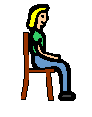  Good sitting |  |  |  |  |  |  |  |  |  |  | 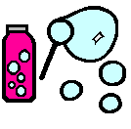
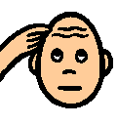  Good thinking |  |  |  |  |  |  |  |  |  |  | 
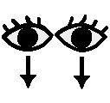  Good looking |  |  |  |  |  |  |  |  |  |  | 

X good listening chart
Good sitting
Good thinking |  |  | 
Good looking

