From the desk of the
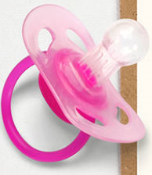
DUMMY FAIRY
Official Certificate

I flew from the enchanted wood
On this very special night,
And found your dummies waiting here
And squealed with great delight!
I’ll polish them with fairy dust,
And they’ll be a good as new,
And little babies everywhere
Will say a BIG THANK YOU!
NAME:
Is a very ‘grown up’ boy! Yes 
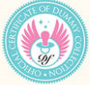
The Dummy Fairy
SIGNED BY THE DUMMY FAIRY

