**Podiatry Services**

Ashingdon House

Rochford Hospital

Union Lane

Rochford

Essex SS4 1RB

Head Office: 01702 538150

**GP Referral Form for Ingrowing Toenails**

EPUT Podiatry Service needs to ensure it provides your patients with the right service at the right time. Please help us to do this by **completing all sections of this form** so that your patient’s treatment is not delayed.

In line with the CCG Service restriction Policy, referrals to EPUT for Ingrowing Toenails will only be accepted for patients with moderate to severe symptoms where primary care management has been tried and failed, at that point a referral can be made. **\*An ingrown toenail is defined as a nail ‘…which pierces the flesh’**. A nail that is curling (involuted or convoluted) into the flesh, but isn’t actually piercing the skin, isn’t a true in-growing toenail.

Moderate-Severe Symptoms include:

• Increased pain and inflammation of the toe

• Purulent drainage

• Bleeding

• Recurrent Infection

• Severe and disabling pain

• Substantial erythema and inflammation

• Severe infection

• Chronic inflammation and granulation

• Nail fold hypertrophy

Please see below for images of what an in-growing toenail may present like. Please do not refer if the patient does **NOT** have an in-growing toenail but is presenting with nail conditions as shown below.

In these cases, please advise patient to seek private conservative treatment.

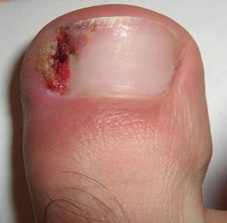

**True IGTN**

**✓**

________________________________________________________

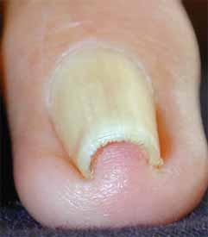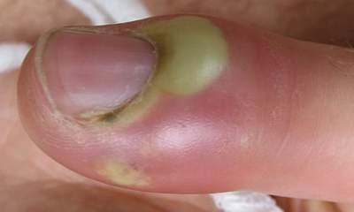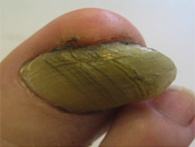

Involuted Nail Onychogryphosis Paronychia

Funding for surgery for ingrown toenails for patients not meeting the above criteria will only be made available in clinically exceptional circumstances and will have to go via the CCG.

**Telephone:** 01375 390044 **E-mail Address:** epunft.southeastpodiatry@nhs.net

Note: EPUT Podiatry services work to NHS Connecting for Health policies and can only send responses including patient identifiable details (PID) to email addresses that are approved by them. If you are not using an approved email address this may limit the response we can make by email.

|  |  |
| --- | --- |
| Date of Referral: | NHS Number: |

|  |  |
| --- | --- |
| **Patient Details** | |
| Forename: | Surname: |
| Address and Postcode: | |
| Date of Birth: | Gender: |
| Home Telephone: | Mobile Telephone: |
| Ethnicity: | |

|  |  |  |  |  |  |
| --- | --- | --- | --- | --- | --- |
| **Disabilities (please indicate relevance to this referral)** | | | | | |
|  | Learning disability |  | Physical impairment |  | Sensory impairment |
|  | Mental Health condition |  | Longstanding illness |  | Other |
| Additional Information: | | | | | |

|  |  |  |  |  |  |
| --- | --- | --- | --- | --- | --- |
| **GP Details** | | | | | |
| Registered GP: | Telephone: | | | | |
| GP Practice or F Code: | Fax: | | | | |
| Have they received NHS Podiatry/Chiropody previously? | |  | Yes |  | No |
| If yes, when: | and where | | | | |
| Does the patient meet the above criteria for IGTN? Yes/No  If Yes please tick the one/s they meet  The nail is piercing the flesh  Increased pain and inflammation of the toe  Purulent drainage  Bleeding  Recurrent Infection  Severe and disabling pain  Substantial erythema and inflammation  Severe infection  Chronic inflammation and granulation  Nail fold hypertrophy | | | | | |
| How long has this problem been there and what measures have already been tried? | | | | | |
| Is the patient happy to have the procedure undertaken under a local anaesthetic? Yes/No | | | | | |
| **If possible, please also supply an image of the toenail/s to enable us to triage effectively** | | | | | |

|  |  |  |  |  |  |
| --- | --- | --- | --- | --- | --- |
| **Medical History** | | | | | |
|  | Allergies. |  | Diabetes |  | Kidney Disease |
|  | Rheumatoid Arthritis |  | Poor Circulation |  | Registered Blind |
|  | Heart/Stroke |  | Neurological Disorder |  | Active Cancer |
|  | Hepatitis |  | Other |  | |

|  |  |  |  |  |  |  |  |  |
| --- | --- | --- | --- | --- | --- | --- | --- | --- |
| **\*\*\* Mandatory section for Diabetic patients –**  **We cannot accept referrals without this information \*\*\*** | | | | | | | | |
| 1. Diabetes |  | | Yes | | |  | No | |
| If yes, please complete the following: | | | | | | | | |
| How long have they been diagnosed with diabetes? | | | | | | | | |
| Date of last diabetic annual foot check: | | | | | | | | |
| Palpable pulses: | | | | R/F | L/F | | | √ = Palpable pulses |
| Dorsalis pedis | | | |  |  | | | X= Absent pulses |
| Posterior Tibialis | | | |  |  | | | √= Normal sensation |
| Monofilament test: | | | |  |  | | | X= Impaired sensation |
| **HbA1c results:** | |  | | | | | | |

|  |  |  |  |  |  |  |  |
| --- | --- | --- | --- | --- | --- | --- | --- |
| 2. Neurological disorder |  | Yes | | | |  | No |
| If yes, what type? (e.g. Parkinson’s, Multiple Sclerosis, Stroke) | | | | | | | |
| 3. Vascular Disease | | |  | Yes | |  | No |
| If Yes, what type? | | |  | | | | |
| 4. Other - please specify anything not listed above (e.g. allergies, cancer, learning difficulties, COPD) | | | | |  | | |

**Medication**: **Please attach a list**

|  |  |  |  |
| --- | --- | --- | --- |
| **Language** | | | |
| Main spoken language |  | | |
| **Referrer Details** (complete if not patient’s GP) | |  | Tick if patient’s GP |
| Name: | | Job Role: | |
| Organisation\Service: EPUT Podiatry services  (South East Essex) | | Telephone: | |

**Return completed forms to:**

EPUT Podiatry Services

Ashingdon House

Rochford Hospital

Union Lane

Rochford

Essex SS4 1RB

**E-mail Address:** epunft.southeastpodiatry@nhs.net