

FOOTWEAR ADVICE

**CONSIDERATIONS ABOUT FOOTWEAR**

* Footwear is designed to protect your feet and should feel comfortable from the first use.
* It is a good idea to buy shoes in the afternoon as feet may swell during the day.
* If you wear insoles or orthoses prescribed by your Podiatrist or other healthcare provider you have to ensure shoes have enough room to accommodate these. This can be achieved by buying shoes with a removable inlay.
* Socks are also advisable for an extra layer of protection and to help prevent blisters.
* Shoe size will vary between shoe type and manufacturers.
* Many MSK Foot and lower limb conditions can be affected by poor footwear choices.

**HOW TO CHOOSE PROPER FOOTWEAR**

* Well fitted shoes means the correct length, depth and width.
* Make sure your footwear has the following characteristics:

1.  strong heel counter (this should bend to a maximum of 45 degrees)
2. A functional fastening, preferably laces which can be tightened and loosened and these should be located to the mid foot.
3. The shoe should bend at the level of your big toe joint; 1st Metatarso-phalangeal joint (ball of foot joint).
4. You should not be able to fold your footwear in half or wring this out like a flannel.
5. Always check your shoes for foreign bodies, inside and imbedded within the sole and replace them when there are signs of wear and tear that cannot be repaired.

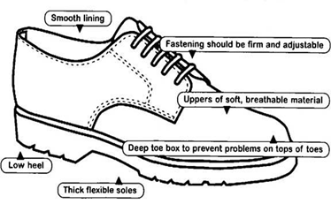

**HIGH HEELS AND SLIP ON’s—WHAT YOU NEED TO KNOW**

* The position of the foot in the shoe and an often narrow heel width can cause the ankle to become unstable, resulting in ankle sprains.
* The Calf muscle may shorten and tighten over time. The body compensates for this tightness in the calf muscles by lowering the arch of the foot or by affecting the knee, hip or back.
* High heels can throw weight onto the ball of the foot, which may lead to callus, painful bunions, corns or toe deformities.
* Slip on shoes do not provide any support for the feet often increasing their work load. Toes have to claw to grip the shoe to prevent these from falling off.

Useful contacts

* **Asics Trainers -** Visit the website www.asics.co.uk
* **Nike Trainers -** Visit the website www.nike.com
* **New Balance -** Visit the website www.newbalance.co.uk
* The Clarks Shop - visit the website www.clarks.co.uk/Storelocator
* **Cosyfeet** - Tel (01458) 447275 (Wide fitting shoes,sandals & slippers. Sundries including no elastic socks)
* **DB Shoes** - Tel (01933) 359217 www.dbshoes.co.uk. (Extra wide men & ladies shoes)