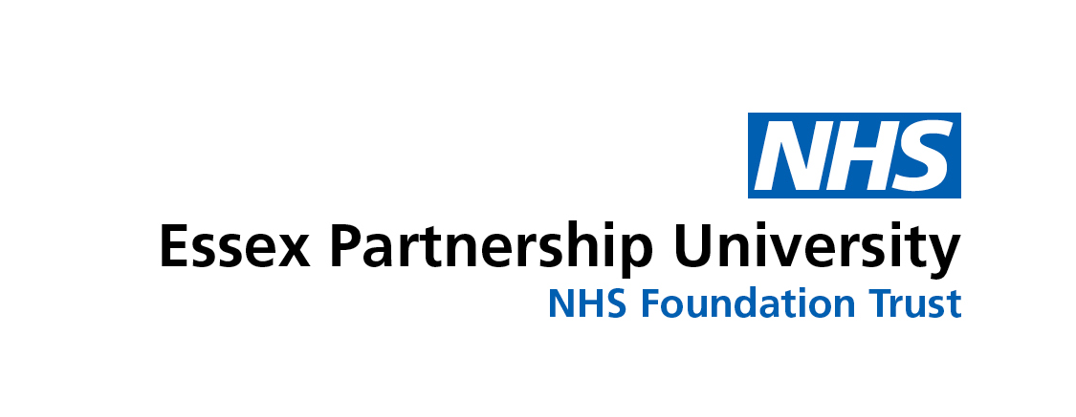


Do you have Type-1 Diabetes?

“D A F N E”
may be able to help you

“Everyone should be

offered the opportunity

to do this!”

What is “DAFNE”?

DAFNE stands for: Dose Adjustment For Normal Eating

It is a way of managing your diabetes by working out how much insulin you need to take for what you want to eat. It is based on:

- 1-2 injections of long-acting (background) insulin each day
- Injecting quick-acting insulin each time you eat
- Testing your blood sugar level before each injection

“It’s given me the real reason

for doing blood tests!”

This approach has been used in Europe since the 1980’s and was introduced in Britain in 2000, funded by Diabetes U.K. (British Diabetic Association).

DAFNE has proven to:

- Reduce HbA1c without increasing the risk of severe hypoglycaemia
- Increase quality of life
- Improve satisfaction with treatment

“How have I managed to survive

before this week?!”

Don’t I already do this?

Many people already have 3-5 injections a day, but often just match their food to the amount of insulin they take. The difference with DAFNE is that it takes away the guess work from choosing your own insulin needs day-to-day and mealtime-to-mealtime, so that you can eat what you like when you want to (including not having to eat when you don’t want to). DAFNE also gives you the skills to manage things like exercise, illness and alcohol more safely.

“I have realised how haphazard things have

been since I was first diagnosed”

What does it involve?

DAFNE involves either attending an online course spread out over one day a week for 5 weeks, comprising of 3 hour sessions (9.30am – 12.30pm), with around 5 other people with Type-1 Diabetes, plus an online follow-up session approximately 6 weeks after the course

- or -

A 5-day course (9.30am - 5.00pm) spread out over a five-week period or 5 days in one week (Monday to Friday), both held at St. Margaret’s Hospital, Epping, again with around 5 other people with Type-1 diabetes, plus a follow-up session approximately 6 weeks after the course.

The structured teaching programme covers topics including carbohydrate estimation, blood glucose and ketone monitoring, insulin regimens, eating out, reading food labels, hypos, illness and exercise.

The DAFNE course is about learning from experience. During the programme, you will practice the skills of carbohydrate estimation and insulin adjustment under the supervision of DAFNE-trained Diabetes Specialist Practitioners.

”I understand what I am controlling”

Most of the training is built around group work, sharing and comparing experiences with other people with Type-1 diabetes. However, there are also opportunities for each person to speak to a doctor or Diabetes Specialist Practitioner individually.

“I’ve learnt such a lot in a short space of time –
and I’ve had a bit of a laugh as well!”

What are the “costs”?

Structured education is now seen as part of routine diabetes care. The Government recommends that everyone with diabetes should have access to this type of structured education through the N.H.S. You may need to re-organise family commitments or take time off work to do the course. However, we can provide a letter of explanation for your employer.

What else is involved?

Before undertaking a course, you will be required to attend a telephone appointment with one of the DAFNE Educators (a “pre-course assessment”), including an arrangement to have some blood tests taken and for advice on how you may need to adjust your insulin in preparation for the DAFNE week. You will be asked to complete a questionnaire before and after your course, so that we can monitor the effects of DAFNE on your quality of life and overall diabetes control. There may also be doctors, nurses or dietitians ‘observing’ courses to learn how to teach DAFNE themselves.

What if I decide it’s not for me?

A small number of people who attend the DAFNE course choose not to carry on with the whole approach at the end. However, they find the time very useful and the skills learned still help to manage their diabetes day-to-day. Whatever you decide, you will still be offered the same level of support and treatment from your diabetes clinic.

“At last, I now have the
freedom to choose”

For more information, or for course dates, please contact:

Joanne Gallagher
Diabetes Education Co-Ordinator
West Essex Specialist Community Diabetes Team
Essex Partnership University N.H.S. Foundation Trust
2nd Floor, Epping Forest Unit
St. Margaret’s Hospital
The Plain, Epping
Essex, CM16 6TN

Tel:
Direct: 01279 973705

E-Mail:
joanne.gallagher@nhs.net
epunft.wex.communitydiabetes@nhs.net

DAFNE Educators / Diabetes Specialist Practitioners:
Sema Jethwa (DAFNE Lead)
Jean Duffell
Rosemond Kyere-Diabour
Lovenia Shanley
Ann-Marie West

www.dafne.nhs.uk

